How to Open and Submit Online Timed Assessments in Blackboard

Guide for Students

There are 3 main steps that need to be followed.

- Login to Blackboard and go to the relevant module where you will find at the top of the Content area a folder named ‘Timed Assessment’ (see below).

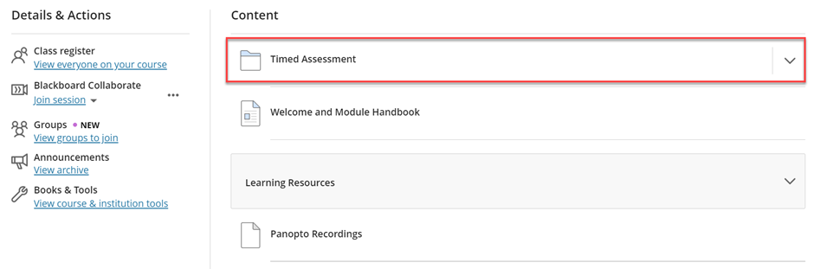

- Inside this folder, you will find the online timed assessment paper (see example below), which includes the questions and any instructions. This will become available to you at the time that the online timed assessment is set to start and remain available for 24 hours. Some online timed assessments will need to be completed in less than 24 hours, which your Module Leader will confirm if this applies to your assessment.

You can download the online timed assessment paper to open it offline on your computer.

Please remember, however, that you can remain online and if you have any queries for the Module Leader relevant to the assessment; you can use the Discussion board (see picture below) made available in the same Timed Assessment folder

- In the ‘Timed Assessment’ folder you will also find an assessment submission link (see example below). This will be available to you for 24 hours from the time the online timed assessment starts. Some online timed assessments will need to be completed in less than 24 hours, which your Module Leader will confirm if this applies to your assessment.

To submit your exam, click on the ‘Timed Assessment’ submission link and follow the instructions you see on-screen. An example of a submission link is shown below:

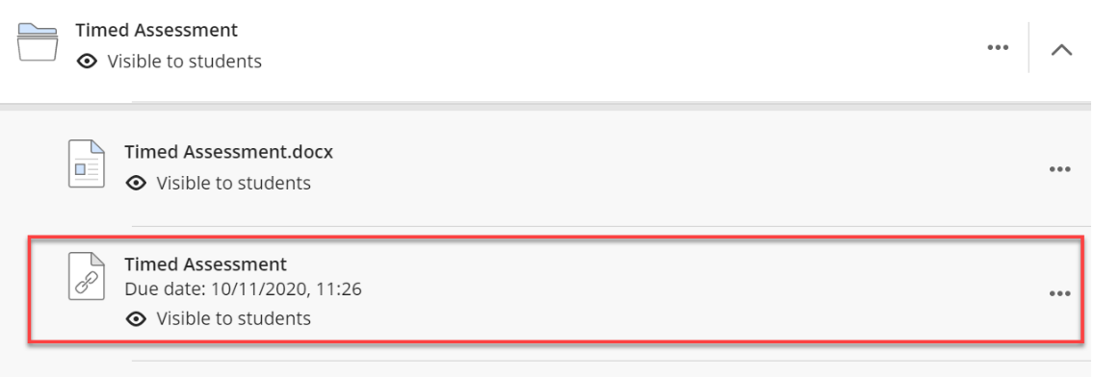

You must submit within the 24-hour period given to you (or alternative time period allowed as advised by your Module Leader). Please ensure you follow all the steps to get a digital receipt of your submission. One submission counts as one attempt, so if you accidentally submit the wrong file, you have one further opportunity to submit the correct file before the deadline.

For this assessment, only one attempt will be graded, and in case of multiple attempts, only the last one submitted will be accepted for grading (you cannot amend the file after the deadline has passed).

- Links to more detailed guides on using Blackboard and the submission of work via Blackboard can be accessed via the links below.

- Accessing and Navigating Blackboard
- Online Assignment Submission

Frequently Asked Questions

- Where do I find my exam timetable?
Exam timetables can be found here: https://www.westminster.ac.uk/current-students/studies/exams-and-coursework/exam-timetables

- How do I find my online timed assessments on Blackboard?
Your exam ‘Timed Assessment’ submission link will be available in the ‘Timed Assessment’ folder at the top of the Content area of your relevant Blackboard module site.

- What if I am ill/caring for someone?
If you are unwell or unable to complete an academic assessment as a result of following advice that you must self-isolate, stay at home or caring for someone, you should use the mitigating circumstances procedure.

- What if I have a disability and concerned about my upcoming timed assessment?
If you have a disability and are registered with the Disability and Learning Support Team and have concerns about your upcoming timed assessment, please get in touch with DLS: studentcentre@westminster.ac.uk Further information can be found in the Exam and Assessment FAQs.

- Do I have to complete it online, or can I upload files?
You should upload your submission in a Microsoft Word format (unless otherwise advised by the module leader) using the assessment submission link found in the Timed Assessment folder of the relevant Blackboard site. Your Module Leader will provide specific instructions if you have to embed pictures or diagrams.

- What if I don’t understand what I have to do? Where do I get help?
During the first 2 hours of the timed assessment period, your Module Leader will be available to answer any queries you may have about the examination, via the Discussion Board provided in the same ‘Timed Assessment’ folder of the relevant Blackboard site. Academic staff will also check the discussion board at periodic intervals during the 24-hour period in order to support students in different time zones.

- What if I can’t get online, or if my connection drops?
You should use the mitigating circumstances procedure to request a deferral for the assessments that you are not able to complete.

- How long should I take? I can’t spend 24 hours!
Your Module Leader will provide information on the amount of time you should spend on the examination within the 24-hour window. You should however not leave submitting your answers until the very last minute. We recommend that you start the submission process at least 1 hour before the end of the 24-hour period.

- Can I write as much as I want?
Your Module Leader will provide an indicative word count for each question to give you a guide on how much you should be writing.

- Will you check for plagiarism?
Yes, plagiarism detection software will be in use. As you will have access to resources to complete your assessment any content you use from external source materials will need to be referenced correctly. Whenever you directly quote, paraphrase, or summarise someone else’s ideas, you have a responsibility to give due credit to that person for their work. Support can be found at https://www.westminster.ac.uk/current-students/studies/study-skills-and-training/research-skills/referencing-your-work
Where the University believes that academic misconduct has taken place the University will investigate the case and apply academic penalties as published in Section 10 Academic Misconduct regulations.

- Can I work with others to complete the exam?
This is an individual piece of work so do not collude with others on your answers as this is an academic offence.
Where the University believes that academic misconduct has taken place the University will investigate the case and apply academic penalties as published in Section 10 Academic Misconduct regulations.

- Can I submit my work after the deadline?
Work submitted after the deadline will not be marked and will automatically be given a mark of zero.

