Google Chrome

- Click the Tools menu (three dotted lines in the upper-right corner).
- Select History.
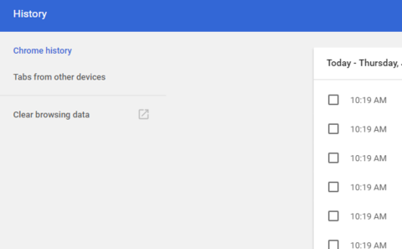
- Select Clear Browsing Data from the left-hand side. Set the Time Range set to All Time. Check-mark Cookies and other site data and Cached images and files and select Clear Data.
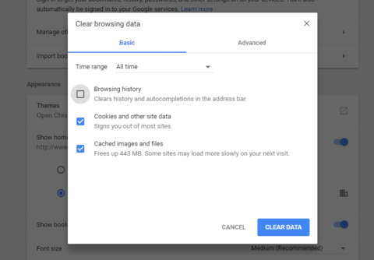

- If on a Windows computer, close and re-open Chrome to save your changes. If on an Apple computer, go to the Chrome menu on the top menu bar and select Quit for the changes to take effect.

Mozilla Firefox

- Click on the Tools bar.
- Click on Settings
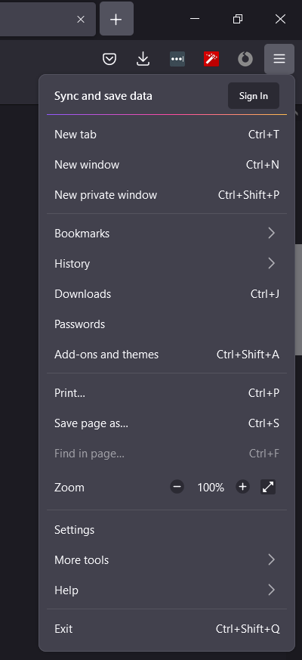
- On the menu to the left, select Privacy & Security.
- Under the Cookies and Site Data option, click the "Clear Data..." button.
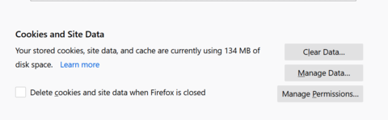
- Select only the two options and hit clear now.
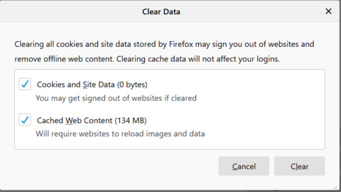
If on a Windows computer, close and re-open Firefox to save your changes. If on an Apple computer, go to the Firefox menu on the top menu bar and select Quit for the changes to take effect.

Microsoft Edge for Windows 10

- Click the Tools menu (three dotted lines in the upper-right corner), and open the Settings menu.
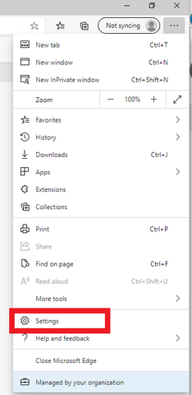
- Click Privacy, search, and services on the left-side menu.
- Under the section Clear browsing data, Click Choose what to clear.
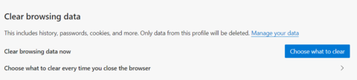
- Select Cookies and other site data and Cached images and files.
- Click Clear Now.
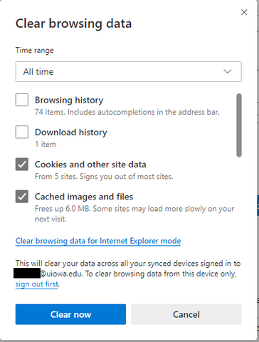
- Close Microsoft Edge completely for your changes to take effect.

Disabling Notifications
Chrome
1. From the top-right drop-down menu, choose Settings.
2. From the settings menu, choose “Advanced Settings”
3. From Advanced settings, choose “Content Settings”
4. Open "Notifications"
5. Find the unwanted site allowed to push notifications and disable / remove.
Firefox
6. Click on the top-right drop-down menu and choose Options.
7. From “Settings”, type “notifications” in the search box
8. click on settings to the right of notifications
9. Find the unwanted site allowed to push notifications and disable / remove.
Edge
10. Open Edge.
11. Click the More button in the top-right corner of the window.
12. Click Settings.
13. Click View advanced settings.
14. Click Manage, located beneath **Notifications.
15. Click the switch below the website name so that it turns off.
For any browser extension, the remediation is similar in nature, however you'd go into the settings menu and then to Extensions to review.

