Application Form

Thank you for considering applying for a Green Fund scheme. Please answer all of the questions in the form and email it to GreenFund@westminster.ac.uk by 12pm, 29th November 2021.

Project Title:

Project Team

 | Name | Email | College/School & level of study
Student Partner 1
Student Partner 2
Student Partner 3

Student Partner 4

 | Name | Email | College/School/Department  /Team
Staff Partner 1
Staff Partner 2

Staff Partner 3

- Project Topic

- Please provide a summary of your project. (100-150 words)

- What are the aims of your project? Tell us specifically what your team wishes to achieve in the process of undertaking the project. (150-250 words)

- Project Impact

- Why is this project important for you and other students at Westminster? (150-250 words)

- How does your project align with the 17 United Nation’s Sustainable Development Goals (SDGs) and/or the University’s core values and Sustainability Policy?

- Please identify at least 3 SDGs that this proposed project would contribute to:

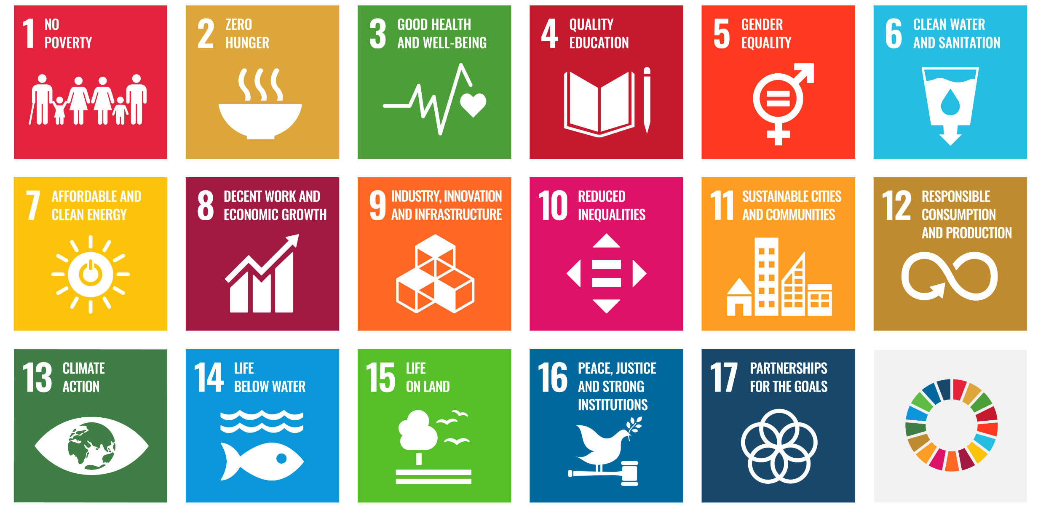

- Describe the key methodologies you will use to achieve the aims of your project. (150-250 words)

- How innovative if your project? Please provide in detail how your proposed project will offer an innovative outcome and/or solution to a problem. (100-150 words)

- Project Management

- Please confirm a team meeting has taken place with all the Partners listed on this application form to discuss the project and the application. List the names of those present at the meeting and the date of the meeting:

- How will the Partners in your team communicate to manage the project and share its workload? (100-150 words)

- Please provide an itemized budget required of your proposed project with as much detail possible. (50-100 words)

- Please provide a timeline of your proposed project with as much detail possible. (100-150 words)

- Please provide an evaluation plan of your proposed project with as much detail possible. (150-200 words)

Next Steps and Key Dates
A selection panel will meet to assess the applications. You will receive the outcome of your application via email by the 10th of December 2021. If your application is successful, your team will be required to attend mandatory introduction workshops on the w/c 17th of January. Below are all the key dates and timings you need to keep in your diaries:
Project Timeline for 2021/22

For further information and guidance on completing your project submission please contact: GreenFund@westminster.ac.uk.
Dr Andrew Pitchford
Head of Centre for Education and Teaching Innovation

Dain Son Robinson
Sustainable Development Goals Coordinator

