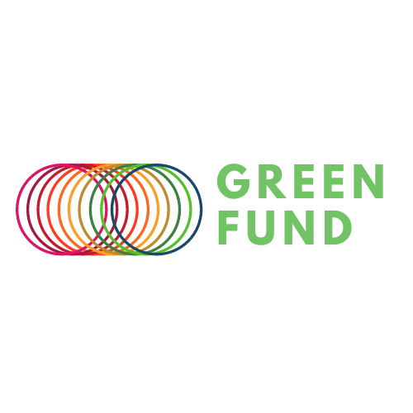

Green Fund 2022-2023

Application Form

Thank you for applying to the Green Fund. We look forward to reviewing your proposal.

Please answer all questions and prompts in the application form and email the completed version to [GreenFund@westminster.ac.uk](mailto:GreenFund@westminster.ac.uk) by **12pm, Monday 28th November 2022**.

For further information and guidance, please contact [GreenFund@westminster.ac.uk](mailto:GreenFund@westminster.ac.uk).

This application form will follow the format below:

1. Project Identification
2. Project Topic
3. Project Impact
4. Project Management
5. Next Steps

# Project Identification

## 1.a. Project title:

## 1.b. Please use the table below to list your project team (** Student Partners 1-2 & Staff Partner 1 are mandatory). Their name should only be listed if they have already agreed to participate by the time your application is submitted.

|  |  |  |  |  |
| --- | --- | --- | --- | --- |
|  | Name | Student ID | Email | College/School & level of study |
| Student Partner 1 ** |  |  |  |  |
| Student Partner 2 ** |  |  |  |  |
| Student Partner 3 |  |  |  |  |
| Student Partner 4 |  |  |  |  |
| Staff Partner 1 ** |  |  |  |  |
| Staff Partner 2 |  |  |  |  |
| Staff Partner 3 |  |  |  |  |

# Project Topic

## 2.a. Please provide an executive summary of your project. (150-250 words)

# Project Impact

## 3.a. Please describe the perceived problem or need which led you to formulate a Green Fund project proposal. (100-150 words)

## 3.b. What outcomes do you wish to achieve from this project? (150-250 words)

## 3.c. How does your project align with the United Nation’s 17 Sustainable Development Goals? Are there specific goals your project addresses? (150-250 words)

## 3.d. Please describe your approach to achieving the aims of your project. How will you ensure the successful delivery of the project? (150-250 words)

## 3.e. How do you envision the upkeep or further life of your project at the end of the Green Fund cycle in July 2023? (150-250 words)

# Project Management

## 4.a. Communication: How will the partners in your team communicate to manage the project and share its workload?

## 4.b. Budgeting: Please provide an itemised budget required of your proposed project with as much detail possible.

## 4.c. Planning: Please provide a timeline of your proposed project with as much detail possible.

## 4.d. Feedback Loops: Please provide an evaluation plan of your proposed project with as much detail possible. When and how will you measure your successes and setbacks?

# Next Steps

A selection panel will assess applications once the application window closes at **12pm Monday 28th November 2022**. You will receive the outcome of your application via email by Monday 12th December 2022**.**

If your application is successful, your team will be required to attend a session in early January 2023 to workshop your project ideas alongside the Green Fund panel with information regarding how to run your project sustainably.You will also receive a dedicated mentor from the Fund’s panel to follow your project.

Mid-way through the project duration, you will present your team’s progress to the Green Fund panel.

You will present a final poster at a Green Fund event - open to all students, University colleagues and Quintin Hogg Trust members - in late June 2022. To complete the project, a final report and a communication pack - including an annotated deck of images and an abstract with a key image - will need to be submitted in July 2023.

A detailed timeline of key dates will be circulated shortly.