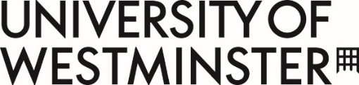

Gender Pay Gap Report (2022-2023)
Gender pay gap reporting requires employers with 250 or more employees to publish statutory information every year showing the pay gap between male and female employees.
For the University of Westminster, the following data was calculated for the snapshot date of 31 March 2023.
The hourly rate for women compared to men
These figures show:
- the diﬀerence between the mean hourly rate of pay of relevant male employees and that of relevant female employees
- the diﬀerence between the median hourly rate of pay of relevant male employees and that of relevant female employees

Mean | Median
6.32% lower for women | 5.00% lower for women

Pay quartiles
These figures show the number of men and women who are in each quarter of the employer's payroll. The lower quartile represents lowest salaries and the upper quartile represents the highest salaries.
 | Men | Women
Top quartile | 50.80% | 49.20%
Upper middle quartile | 49.73% | 50.27%
Lower middle quartile | 46.65% | 53.35%
Lower quartile | 33.20% | 66.80%

Women’s bonus pay
These figures show:
- the diﬀerence between the mean bonus pay for female employees compared to male employees

Mean
69.97% lower

- The diﬀerence between the median bonus pay for female employees compared to male employees

Median
55.16% lower

The proportion of colleagues receiving bonus pay
These figures show the proportions of relevant male and female employees who were paid bonus pay in the relevant 12 month period.
Men | Women
0.74% | 0.73%

