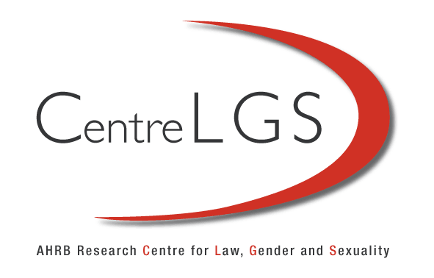

Fatherhood Roundtable
University of Westminster

Along with the growth in notions of parental responsibility has there been a significant development in the legal status of fatherhood?
Does the distinction between fatherhood as a social status and fatherhood as a legal attribution matter?
What are the possibilities for divorcing the uses of birth registration as a historical record and as an allocation of future social roles?
What is the role of marriage with respect to parenting? Does it matter that the legal distinction between married and unmarried fathers is increasingly diminishing?
Can law provide an adequate framework for equality in parenting?
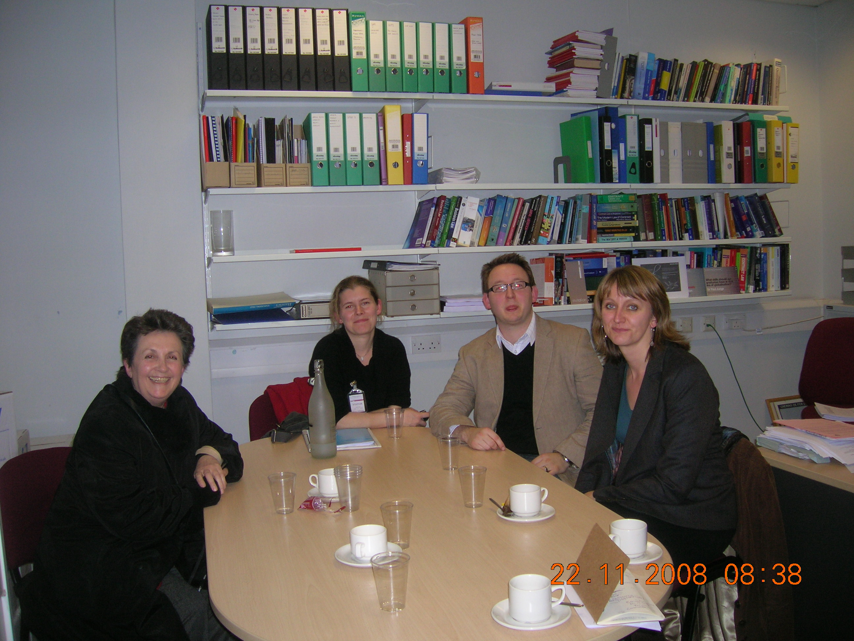

The Panel: Adrienne Burgess, Claire James, Dr Jonathan Ives, Professor Sally Sheldon
Adrienne Burgess is Research Manager for the Fatherhood Institute. She is the author of the book ‘Fatherhood Reclaimed’ and her work focuses on institutional practices and the framing of national policies around fatherhood.
Claire James is a Policy Officer at the Family and Parenting Institute, which researches what matters to families and parents to improve the services families use and the environment in which children grow up.
Jonathan Ives is lecturer at the University of Birmingham. A philosopher by training, he is currently developing a normative framework that attempts to combine practical concepts of fatherhood with theoretical reasoning.
Sally Sheldon is based in the Law School at the University of Kent. Her research is in the areas of fatherhood, reproduction and the law and she has recently published a book entitled ‘Fragmented Fatherhood: A Socio-Legal Study’ (co-authored with Richard Collier).
Dr. Oliver Phillips is Reader in Law at the University of Westminster. His research interest is in the area of sexuality and the law.
Oliver Phillips: Given the growth in the notion of parental responsibility in recent years, what is your understanding of current policy proposals on the joint birth registration process? To what extent are these proposals indicative of broader trends in the regulation of fatherhood?
Adrienne Burgess: From an organisational point of view, it is incredibly useful for us to identify situations where a mother doesn’t want to give the name. From a child’s rights point of view, we should encourage the mother to put down the father’s name unless it’s an extraordinary circumstance.
Sally Sheldon: I see various trends over the last years. Firstly, there’s an ironing-out of the differences between married and unmarried fathers. Traditionally, married fathers were under a joint legal obligation to be registered at the birth of the child, whereas unmarried fathers had no such obligation. So you could see this reform as working towards equality between married and unmarried fathers. Secondly, there’s an effort to ensure equality between men and women here: the idea is that we should have the same set of expectations for mothers and fathers, and this fits closely with the increasing powerful notion that the child should have a right to genetic truth: an idea we see replicated in debates on donor anonymity as well. As part of this, there has also been an increased mandate for service providers to engage with fathers. But I am concerned about the legal implications of the government’s growing initiative to engage with fathers because there is a considerable confusion as to what it means to be named on a birth certificate in this country. Legally we don’t know whether this is just a statement, a record of genetic fact, or whether it’s a statement of social parenting roles for the future. Since we have now attached the legal acquisition of parental responsibility to birth registration, if men are named they get legal rights allowing them to make decisions regarding a child.
Jonathan Ives: My concern around the rhetoric on rights is a moral one. By giving people rights the hope, one assumes, is that they will also take on responsibilities, whereas it seems to me that if we want to encourage good fathering – as in a carer figure who is involved in nurturing - we should be encouraging and enabling men to take on responsibilities first before we talk about rights. The rhetoric around the proposals is, I think, morally misplaced.

Claire James: I agree that there are concerns around the legal changes in parental responsibility. Our concerns are with the details in the proposals, especially with the enforcement side.
If you look at the legal status of parental responsibility, it reads more like a list or rights but the responsibility of the parent doesn’t seem to be attached. For instance, where a child didn’t attend school the responsibility to ensure education would in practice fall to the parent he or she resided with as opposed to the other parent, so this is unrelated to who is listed on the birth certificate.

Jonathan Ives: The Green Paper also states that children have the right to know that their parents take responsibility for them. This is unclear, as it does not specify what it means by ‘parent’ or ‘responsibility’. On the one hand there’s the material responsibility to provide for a child, which is to my mind really a duty of compensation, which is different from the responsibility to be a meaningful father through loving, nurturing and looking after the interests of the child. These seem to be very different responsibilities, which are not differentiated in the paper.

Oliver Phillips: This raises the question of whether the distinction between fatherhood as a social status and fatherhood as a biological attribute matters. Does a biological link need to be reflected or is the mere supposition of one enough?

Jonathan Ives: If a biological link is important then there should be compulsory parental testing at birth. If it’s important in one case it should be important in all cases, whereas at the moment there seems to be a disjunction between what is considered important for the majority and what’s important for the minority.
Adrienne Burgess: In adoption and artificial insemination cases by a donor, parents have the right to withhold the information from the children of their genetic origins. In my view it should be incumbent on anyone wanting to adopt a child or conceive the child via donor egg or sperm to tell their child the truth about its genetic origins. In cases where parents are unmarried but the father is known to the mother, putting the father’s name on the certificate, of course doesn’t assure the knowledge of genetic heritage, but it opens up chance for the child to know his or her father where the parents split up and the child is not given information abut their dad. It gives them the chance to search for their father, who may in fact be very keen to know them. Research carried out by Gary Clapton shows that men who in the 1960s were very uninvolved in the pregnancy and may even have walked out on the mother, can (even 40 years later) still be thinking about their children and even looking for them and can continue to be very troubled by what happened in the past - this shouldn’t be underplayed. I think biological fatherhood matters a lot to children and to fathers and it’s incumbent on us as a society, and as parents, to keep that connection unless it is unsafe to do so.

Oliver Phillips: Where do you separate the biological from the social if the biological occupies so much space?

Adrienne Burgess: Parental responsibility can be granted through social fatherhood or social motherhood – and doesn’t replace the Parental responsibility held by the biological mother or father. Several people can hold Parental Responsibility at once and it doesn’t detract from the person who already has it by virtue of biology. Actually, the rights it confers to a non-resident parent are pretty limited. For example, parental responsibility doesn't confer an automatic right to contact and this applies both to the mother and the father-if they are deemed unfit to take care of the child there won’t be contact because of the child's best interests.

Claire James: Two of the things you said may show that the process of registering a birth hasn’t caught up with reality. One is the expectation that there would be one man and one woman who are both genetic and social parents, and these roles cannot be be separated. Also, birth registration is usually a one-off process. As you say, particularly younger fathers might not be engaged at first and then become engaged later in life.

Sally Sheldon: If the situation were such that we could simply treat the birth certificate as a genetic record, I would be quite happy about the reform. However I am concerned about the legislative movement from a Government position that advocates parental responsibility for unmarried fathers, conditional upon birth certificate registration on the basis that such registration demonstrates an ‘active commitment’ to parenting, to a position six, seven years later where the Government says that it is aiming to encourage men who are described as ‘merely indifferent’ to fatherhood to get involved in the raising of the child via the birth certificate, which automatically grants them legal rights.

Adrienne Burgess: I think a part of fatherhood is that you support your children even if you didn’t intend for them to be born. The father’s name on the birth certificate has strong implications for child support, as it’s easier to track fathers down and that’s very important from the children’s point of view. We also have to be careful about this idea of indifference, as though it’s a perpetual state and these men remain actively indifferent. The Millennium Cohort Study data is absolutely fascinating because it shows that a third of fathers who were described by the mothers as uninvolved and not interested at the time of the birth have become both interested and involved by the time their children are aged three, whereas a third of non-resident fathers who were described as interested and involved at birth, will have slipped away by the time their child reaches the age of three. So, it’s not a clear cut situation and the government is merely trying to say that fathers matter. This new legislation – requiring the father’s name to be on the birth certificate – has the power to change practice. No woman will go to jail for not revealing the father’s identity but there will be processes attached to identify the father, where this doesn’t pose a risk to mother or child. Such as in Queensland, Australia, where if an unmarried father doesn’t show up at the registration, the authorities will write to him and, in other ways, work quite hard to get his name on the certificate.

Jonathan Ives: I’m all in favour of involving fathers, but I am sceptical about whether this kind of legislative change will actually involve fathers in the way we want. I assume by the term ‘involve’ we mean that they are involved in a nurturing way. But the evidence cited is does not support this reading. All it shows that there is an association in the United States between voluntary registration, child support payment and visitation contact, which is not the same as ‘involvement’ in this broader, nurturing, and arguably more important, sense. The proposals strike me as somewhat theoretical. They seem to be grasping at straws. I hope that legislative change will actually change behaviour, but I also wonder if the money could be better spent on engaging with fathers rather than forcing them to register. As it stands, I think it likely that the changes will reduce the welfare burden on the state, which I think probably is justified, with caveats, but I don’t think it will in itself increase father involvement.

Claire James: My reading of the proposals is that they were drafted with the idea in mind of not wanting to force people into compliance through court cases. But the idea that you ultimately have the sanction to back this up-and I don’t know whether this is the situation in Australia- is disconcerting because what could happen in domestic abuse situations, where the woman, say, had left the man?

Adrienne Burgess: The legislation doesn’t require women to give the father’s name if it is clear from the interview that she is at risk, so in that respect it’s no different to child support legislation where women have had protection through not having to name the father if there’s an identifiable risk. Why would it be different?

Sally Sheldon: That’s an interesting example because one study of the CSA found that child support officers interpreted their role very differently in terms of how much pressure they should put on women to give the name of a father and how willing they were to accept women’s reasons for not wanting to do so. One of my concerns is with precisely what will need to be established so that the woman doesn’t have to give the name of the child support contacts: for example, would be a successful prosecution for rape or domestic violence be required? The Department of Work and Pensions (DWP) has stated that registering the father should become a default presumption unless it can be shown that it’s ‘impossible’, ‘impractical’ or ‘unreasonable’ for the woman to give the name. Inevitably, there’s going to be a lot of discretion left to individual registrars as to enforcement, and we have got to remember that we’re talking about a vulnerable group of women, who are economically, socially and educationally disadvantaged. The conflation of understandings of birth certificates as genetic records and as statements of social or legal roles makes me nervous. The US study mentioned by Jon, and relied on by the DWP, shows an increase in contact without mentioning anything about the quality of the contact. The quality of the contact rather than incidence of contact is what's important for child welfare, so why we think the name on the birth certificate is going to achieve this puzzles me.

Oliver Phillips: But is it possible to divorce the registration process entirely from any social consequences or implications?

Sally Sheldon: We can divorce the names on the birth certificates from the existence of the biological link with a child, which is what we have decided to do in the human fertility embryology legislation, which now allows lesbian couples to be registered as the two parents of a child, as well as heterosexual couples who have received donated sperm. We decided in that context that birth certificates are statements of social/legal rights, rather than genetic facts. Likewise, the Gender Recognition Act allows people to have new birth certificates issued in their new gender identities.

Adrienne Burgess: At the time of birth there are very few men who would be called social fathers who aren’t also the biological fathers and in the few cases where the mother is already in a new relationship by the time of the birth, this tends to be a situation of very high risk for the child – a marker of risk. The fact that the mother has another boyfriend by the time of the birth is a huge indicator of problems to come.

Sally Sheldon: Heterosexual couples who have conceived using donated sperm are usually very successful at not telling their children, unlike lesbian couples who will have that conversation at some point because the situation will prompt the information to come out.

Jonathan Ives: On a philosophical level I would be very interested to know whether you think that it’s bad practice not to tell the child because of an outcome-based objective or based on the fact that the child has a right, regardless of whether there are any social consequences? If the child never found out would that still be problematic and if so why?

Claire James: Studies show that it can be very traumatic for children to find out only later, or even as an adult. I don’t think there’s a fundamental moral right to know - or at least that doesn't concern me as much as the risk of these outcomes.

Adrienne Burgess: The child has a right to know and to be cared for as far as possible by both parents – that’s what it says in the UN Convention on the Rights of the Child. I don’t think our society has been set up at all to care about biological links, except for the link with the mother, but I think society is now discovering the biological links with the father – because now we can! It is no longer a wise child that knows its own father. Any child can.

Jonathan Ives: The rights argument seems to be based on the assumption that the right to know is so intrinsic to the well-being of the child that even if there is no negative social outcome the child would still be harmed. I think the only arguments that work are outcome-linked ones. To my mind the only harm that can come from not knowing your biological parents comes from the societal expectation that the people who raised you are your biological parents. So I would disagree with Adrienne on that point. I think our society is very much focussed now on genetic relatedness, and it is partly this focus that’s causing the problem. If a child doesn’t know their biological parents they feel they are missing out on something. But it is hard to say whether that ‘something’ is an intrinsic good or a socially constructed one. I would say that if even if it is not completely socially constructed, it is certainly socially reinforced.

Oliver Phillips: This leads us to the next issue concerning the proposals that increasingly diminish any distinction between married and unmarried parents. What is the relationship between marriage and parenting? Does it matter that the distinction between married and unmarried people is diminishing?

Claire James: The proposals keep the automatic registration of married men, so take the position that if you are married than you have already committed yourself to some degree of responsibility.

Jonathan Ives: Of course you can escape that commitment if you can prove the child is not genetically yours.

Sally Sheldon: We're much happier with that now. The law used to make it very difficult for married men to rebut that presumption. The courts now tend to take the child’s right to know its genetic identity very seriously. So, they will almost always say it’s in the child’s best interest to know the genetic truth even if that proves that the man whom the child always thought of as the father isn’t the father. One of the things I like about this development in law, though, is that the way we think about fatherhood is now more in terms of a direct unmediated relationship with the child rather than in terms of the commitment you owe to your wife or female partner. But evening out the differences between married and unmarried men is difficult and it’s easier to generalise about married men than about unmarried ones. Although married fathers may vary greatly in their levels of engagement with their children, the spectrum of care is particularly wide-ranging in the context of unmarried (genetic) fathers, as it can range right the way through from the father being the primary caretaker to a one–night stand situation where the man might not even know that he is a father or may have no interest in having any contact with his child or the mother. As such, the regulation of these situations is very difficult.

Oliver Phillips: It is very difficult for people to imagine in advance if they haven’t had children whether they’re going to be able to distance themselves in the way they anticipate. Law is a very blunt instrument with which to try and cope with all these situations, but the constant thread seems to be that the interests of the child should be put first.

Adrienne Burgess: From the point of the service providers it would make a huge difference if the midwives and everyone involved in prenatal care knew that the father's name was supposed to be on the birth certificate, as they would have to think about him differently. The service providers would have to assume that when a mother came in to register her child at a Children's Centre that the father's name would be there. I have yet to hear a convincing argument that the father's name on the certificate does any harm and I don't see the likelihood that it will, given past experience.

Oliver Phillips: What role should the law play with regard to equality between mothers and fathers?

Adrienne Burgess: It’s interesting what technology is doing with bringing men into births - not just the presence at birth but the experience of the scan for men. There is ample research evidence that shows that men can have a strong bond with their babies even though the mother gives birth. The so-called bond mothers have with their baby is, like the father’s, based largely in fantasy because once the baby is born, even for a mother it is usually a tremendous shock. You have to renegotiate the relationship with a living being and that’s why bonding doesn't happen to all mothers straight away.

Claire James: I think legislation can be important in creating a cultural shift in thinking about the relationship of the father to the child, but practical support is even more important. One of the things we have been advocating for at the Family and Parenting Institute is for more health visitors and postnatal support. Mothers sometimes have postnatal depression. It is a difficult time for the couple and the relationship with the baby is a three-way process. Support services have to reflect this in the way they work.

Jonathan Ives: It seems to be connected to the idea of fatherhood becoming less mediated by the mother. However, in the new legislation the mother is still very much the gatekeeper because she can still say that she doesn't know the identity of the father and you would be hard pressed to find registrars who would press her for a response. It’s a very difficult ethical tightrope between a child's right and the need to pressure mothers.

Sally Sheldon: In cases of lesbian couples with a known donor, there is often a much more specific arrangement where the parties talk about their responsibilities before a child is born. As for surrogate situations concerning gay men, fast-track adoption possibilities following surrogacy agreements are being extended. At the moment married couples where one party has a genetic link and where a surrogate has been hired to carry the child don't have to jump over the same hurdles as other adoptive parents because of the fast-track adoption possibility after the child has been born. The same has been extended to unmarried same sex couples and heterosexual couples.

Jonathan Ives: Are there any punitive measures available where the authorities suspect that the mother knows but is not revealing the identity?

Sally Sheldon: The DWP have said that there would be no punitive measures taken against the mother. One other interesting point here is in terms of the relevance of genetic links to how we think about motherhood and fatherhood. We don't think about motherhood in terms of a genetic link: the Human Fertilisation and Embryology Act states that you can't become a mother by virtue of having donated an egg for the child - it has to be a gestational connection. So we think of motherhood in terms of a gestational connection and about fatherhood in terms of a genetic link or something else.

Jonathan Ives: Research from the United States shows that couples looking for a sperm donation try very hard to match donor characteristics, so there is a whole industry trying to hide the fact of donation and protect the image of a heterosexual and biologically-related family. There seems now to be a shift from a focus on the family to a focus on the individual child and that's maybe reflective of a general shift to individual rights away from social responsibility.

Sally Sheldon: What fascinates me most is the idea of how the legislative framework doesn't match the everyday messiness of life and it’s that messiness which makes it so hard to be prescriptive.

Adrienne Burgess: It's very easy to fall into the trap of thinking that changes in the law are manipulating the situation and that what is happening currently just simply “is”. In fact, existing situations bounded by existing laws are already active – are manipulative. The law at the moment is ruling that fathers are absolutely optional extras and that only the mother's position counts. I feel that the child needs every chance in life to know who the “real” parents are because children use those terms all the time.

Sally Sheldon: But those children use the term ‘real parent’ very differently: reading some of the responses surrounding the donor anonymity debate I found that some children will refer to the sperm donors as their ‘real’ father, whereas some will use the term ‘real father’ to mean the guy who gets up in the middle of the night to get them a glass of water. I find the idea that you can only have one ‘real’ father interesting because, while law is trying in many ways to achieve a very nuanced view of fatherhood where different men can have different kinds of rights and responsibilities, people do tend to think of one mother and one father. So that claim to ‘realness’ - to authenticity - is more about exclusivity (in that you can only have one ‘real’ father). The Human Fertilisation and Embryology legislation now says that you have a mother and her lesbian partner can be recognised as a parent but not as a second ‘mother’. I find the idea that you can have two female parents but not two mothers fascinating. What’s a female parent if not a mother?

Jonathan Ives: Sally, do you think that we are actually at the stage where the law recognises two fathers and calls them fathers or is the law recognising that men have various roles to play and can be involved to various degrees?

Sally Sheldon: You can have two men recognised as ‘parents’ on a birth certificate, but not as two ‘fathers’.

Adrienne Burgess: There has been a big move against stepfather adoptions, which are very hard to get these days.

Sally Sheldon: That’s because of wanting to maintain a legal relationship with the birth father. The relationship with the stepfather is still very important but the law tries to deal with that through parental responsibility. But holding on to the number two is very significant because the law says you can only have two parents notwithstanding the messiness of real life and that makes it impossible simultaneously to recognise both the step-father and the birth father as legal father.

Claire James: A child having two male father figures - although not a traditional model - may result in a happy and stable upbringing. Multiple changes are more problematic. I think reliable relationships, or the feeling of not being rejected, are probably the most important factors in the child's well being.

Jonathan Ives: It's again the problem of the unreliable non-resident father, and what rights he should have. I would want to say that morally speaking these men should have no rights, as they have done nothing to earn them. Having healthy sperm seems to me to be no good reason for giving a man rights over a child.

Adrienne Burgess: Yes, but when it's the mother who is unreliable we tend to presume that she loves her child and tend to look at ways in which can support her to be the best mother possible. If the father is unreliable or tends to display negative behaviour we tend to shove him out of the picture.

Sally Sheldon: Having just finished our book, Fragmenting Fatherhood, it seems to me that there's a great deal of policy work focusing on involving men in the family. The question is how well it’s working.

Adrienne Burgess: In social care and services it’s generally not working yet. People who’ve looked at Child Protection cases find that in many cases the father's name is not on the child’s file or it is buried somewhere inside so no-one sees it in an emergency – or the name is there but no contact details. And in other places, say children’s centres or hospitals, no-one records the name of the father at all! Especially at local policy level, fathers are missing. For example, Local Authorities’ Children and Young People Plans hardly ever include stuff about working with the fathers, or even recording their names. So there is a huge disjunction between care services and government policies.

Jonathan Ives: Adrienne, is there a point when intervention to try and get fathers involved becomes unworkable?

Adrienne Burgess: Certainly, but I’d love to see some real efforts to get them involved first, before we decided to focus on when it would be unworkable!

