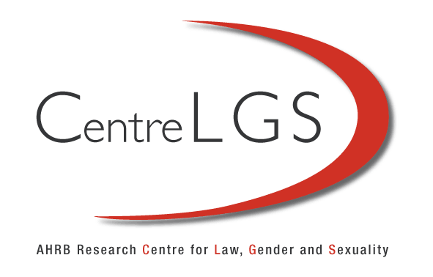

Conversation: Gender, Human Rights and International Law
With Professor Hilary Charlesworth, Australian National University, Gita Sahgal, Gender Unit, Amnesty International and Kathryn Lockett, Programme & Policy Manager - South Asia, Womankind, May 16th, University of Westminster

Selection of Questions Discussed During the Conversation

Introductions to work, organisation and activism. What drew you to this area of work?

How do you think international law in general, and peacekeeping missions and peace agreements in particular address gender issues? And as part of that, what are the problems and advantages gained of using international law and international human rights law in particular to address gender issues?

How do we as academics and practitioners use these local examples, engage with these local examples but also use the global framework – how do those possibilities and also tensions come across in the sorts of work that you do?

What are differing roles, complementary roles, between academics and practitioners/activist in terms of the ways we're using these the framework and concepts of International Law.

Is women’s contribution to peace building tailored differently in developing states compared to developed states – for example, between East Timor and Northern Ireland? For example the Women’s Coalition in Northern Ireland were crucial to arriving at the Belfast Agreement, thereafter they disappeared from the political landscape.

Please note the ‘transcript’ provides a largely verbatim account of the discussion. But in some places a summary of the answers to the questions is given. For the full answers please go to the recording.

Welcome by Harriet Samuels, Associate Director of the AHRC Research Centre for Law, Gender and Sexuality: Good afternoon everyone, I’m Harriet Samuels, Associate Director of the AHRC funded Centre for Law, Gender and Sexuality here at the University of Westminster in London. I’m delighted to introduce the first in our series of conversations. The aim of the conversation series is to exchange ideas between policy makers, academics, non-governmental organisations and activists. The hope is that it will increase understanding of the various fields of work and study. It provides an opportunity for everyone to participate, explore and exchange ideas, information and experiences.

Today’s conversation focuses on gender, human rights and international law. The conversation will be around 50 minutes of discussion between the participants followed by 10 minutes of questions from our small invited audience of graduate students and interns. I’d like now to give a very warm welcome to our participants, Professor Hilary Charlesworth from the Australian National University who is a Professor of human rights and international law and Professor and Director of the Centre for International Governance and Justice in Regulatory Institutions Network, Gita Sahgal from the Gender Unit of Amnesty International, International Secretariat and Kathryn Lockett from Womankind. The session will be facilitated by Dr Zoe Pearson, lecturer from the University of Keele, who lectures in international law. So I'll turn over to Zoe.

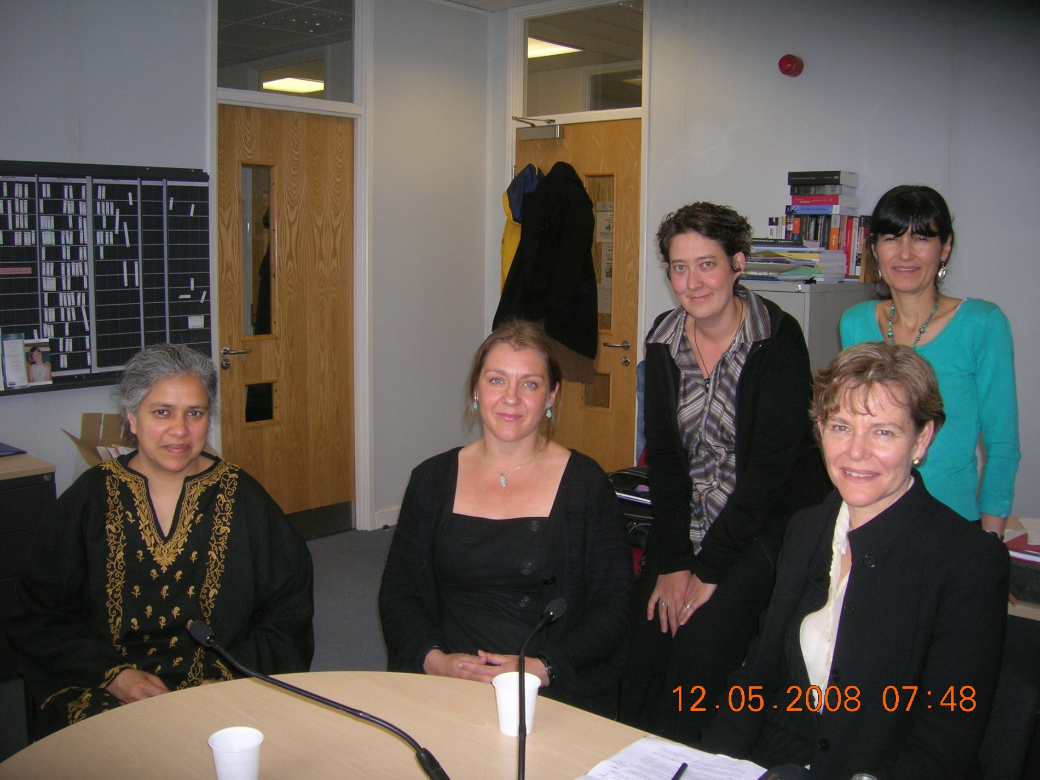
Front Row: Left to right Gita Sahgal (GS) Kathryn Lockett (KL), Hilary Charlesworth (HC) and back row: Zoe Pearson and Harriet Samuels

ZP: Thanks very much Harriet. Just to get things started then – by way of general introduction for everybody would you be able to introduce yourself, saying something about your organisation and the sort of work that you do in your position. We’d also be grateful if you could say something about what attracted you to the area of policy/activism or research.

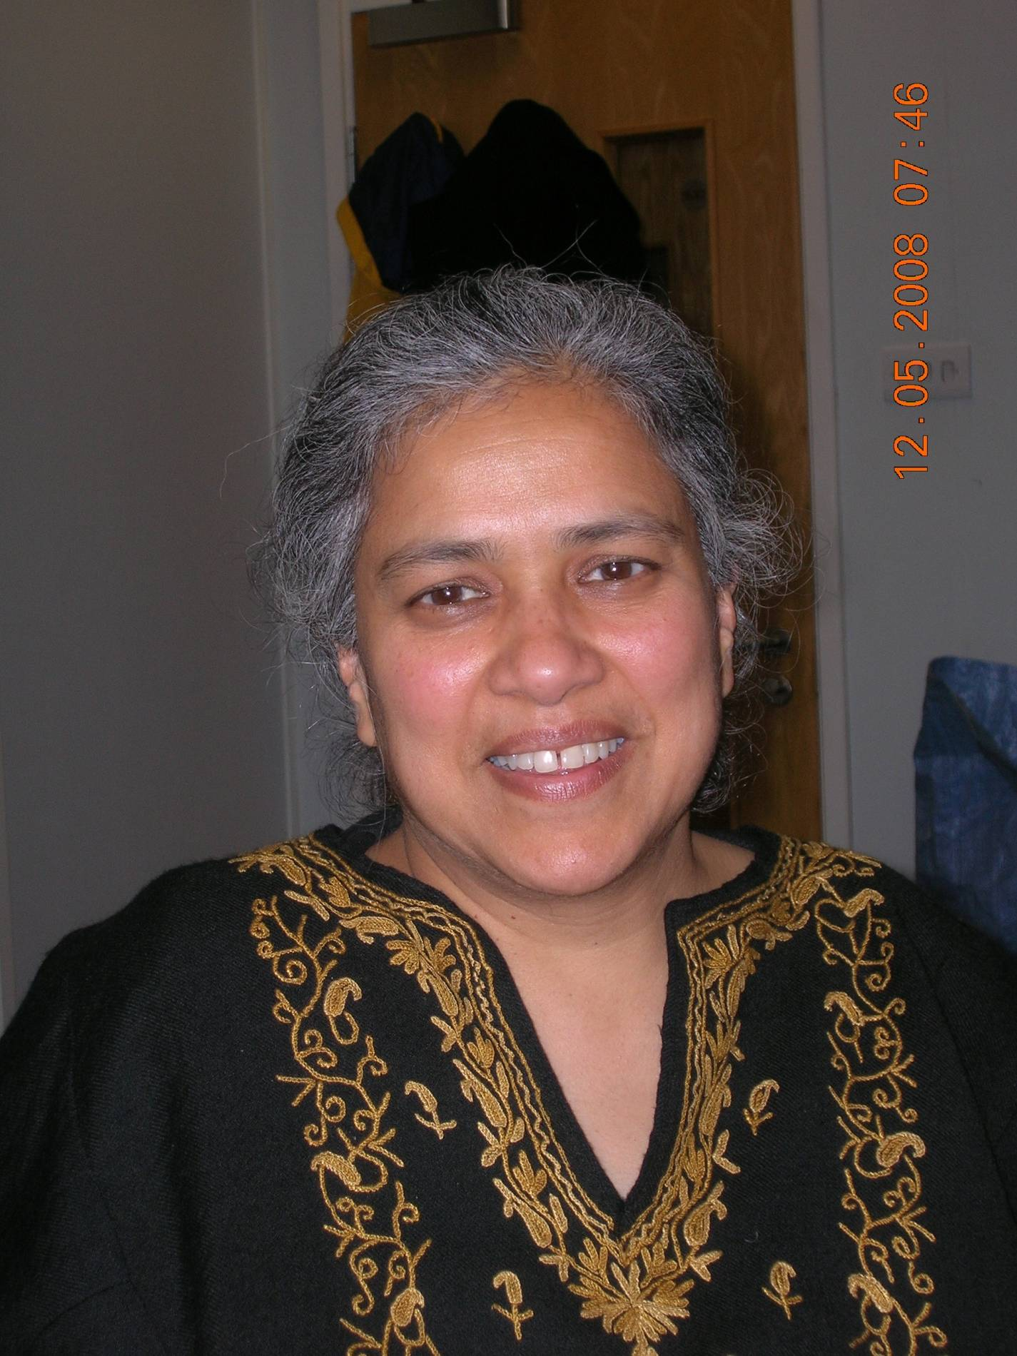
Gita Sahgal, Head of the Gender Unit at Amnesty International

GS: I’m Gita Sahgal, head of the Gender Unit at Amnesty International’s International Secretariat. Ihttp://www.amnesty.org/
I work on all policy issues concerning gender which is often interpreted as women’s human rights but which, of course, is a wider brief than that.

I was attracted to this area of work through a rather strange route. I worked for most of my life as a freelance filmmaker and writer and worked on many issues that are pertinent to the issues that I work on at Amnesty International, such as investigative films on war crimes, women who kill their husbands and other issues concerning multiculturalism, fundamentalism, race and gender all of which are pertinent to Amnesty International’s work and wider work on women in conflict.
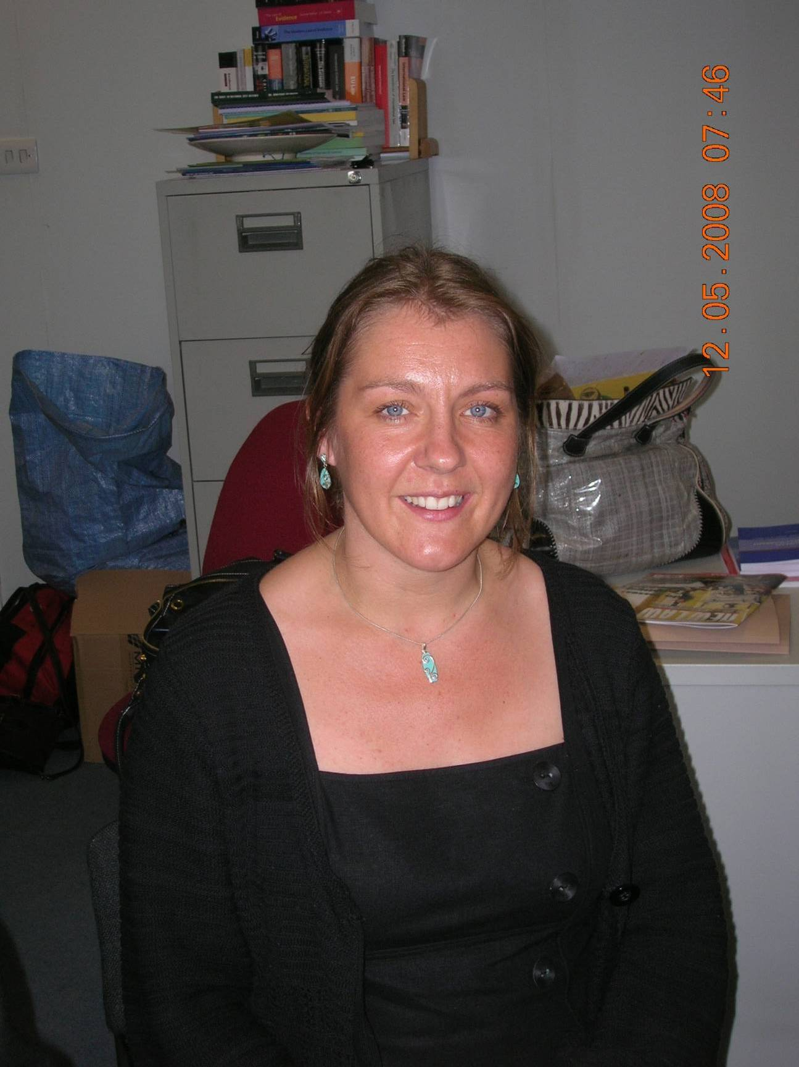
Kathryn Lockett, Programme & Policy Manager - South Asia, Womankind
KL: Womankind works with about 32 partners in 14 countries worldwide and we work through local women’s organisations. http://www.womankind.org.uk/
I manage our programmes in Afghanistan and India. My background is working with local organisations overseas in post-conflict and transitional states such as Afghanistan, Nepal and Kurdistan. One of the most powerful things is the contribution that local civil society plays in holding governments accountable; security sector reform, legal reform and showing a very active role that woman can play in changing their situation. I have a particular interest in how gender issues play into violence, militarisation and generally how it manifests in the causes of violent conflict as well as continuation of violence from a household, to a community, to a state to an armed conflict.

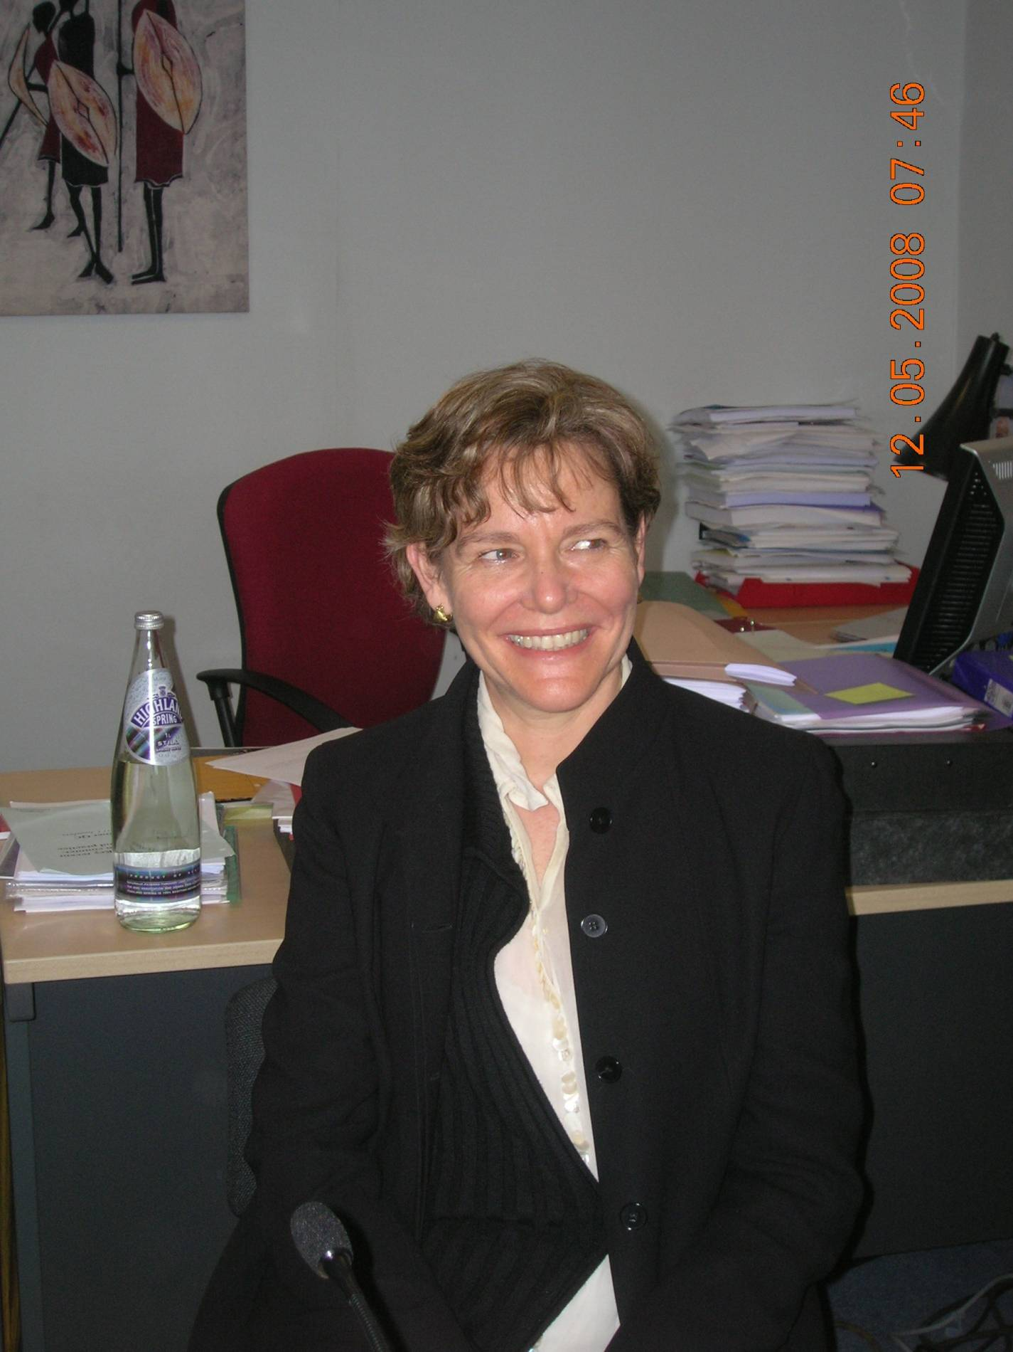
Professor Hilary Charlesworth

HC: I’m Hilary Charlesworth and I’m an academic – the token academic in this conversation! I suppose as a feminist you’re probably inevitably an activist but that is the only sense I count myself as an activist for I’ve been in the academy for 20 years. http://cigj.anu.edu.au/cigj/people/staff/charlesworth.php/

I trained as an international lawyer and I first encountered feminist theories applied to law during graduate work in the US. This was quite a revelation as I did a black-letter law degree in Australia. During my graduate work in the 1980’s – when feminist ideas about law were beginning to permeate the academy. For quite a long time I had thought that these theories – while they were fascinating – had no implication for international law. International law is all about states and I saw them as two very separate interests. It was really meeting Christine Chinkin – at a conference 20 years ago – who was also an international lawyer interested in feminist theories – when we said ‘what a shame feminist theory has nothing to say to international law’. It was really to annoy our male international law colleagues that we decided, along with a colleague Shelley Wright, to offer a paper ‘Feminist Approaches to International Law’ for the annual International Law Conference in Australia. We assumed that they would say no but they said yes, that sounds really interesting and we had to then think about what we were going to say. So for me coming into this was very much from an academic perspective. I’m really conscious that my knowledge - which is why I'm looking forward to this conversation - doesn't really stem from practical knowledge. Although the particular project I’m involved in is on peace building and peacekeeping, I have visited countries in the Pacific and Asian region near Australia but these are academic visits and not working in these countries and so my knowledge of them is pretty thin.

ZP: I’ve grouped the questions which we want to explore today into three areas. Firstly, thinking about international law and gender and the connections there, secondly thinking about the connections between local experience and global issues and thirdly reflecting on more closely the respective and perhaps complementary roles and responsibilities of academics and activists/practitioners/policy makers.

So just to start off the conversation around the first theme – international law and gender – and the first question: from your varied perspectives how do you think international law in general and peacekeeping missions and peace agreements in particular address gender issues? And as part of that, what are the problems and advantages gained of using international law and international human rights law in particular to address gender issues?

KL: International law and the framework in place – the Convention on the Elimination of Discrimination against Women (CEDAW), UN Security Council Resolution 1325 and the Rome Statute – generally speaking provide a very strong framework and local organisations do use them – for their approaches at national level and as an advocacy tool to implement international legislation and post conflict settlements and new constitutions. The main problem is implementation which is very poor whether or not that is whether the country has signed up to or not whether or not there is integration at national level in terms of what governments are doing and whether or not they put the resources behind these instruments to make them work.

From our experience we find that women are often very much sidelined in peace agreements. For example, one of our partners, Save Somalia Women and Children, (http://www.sswcsom.org/) when looking at the Somalian peace process found that women were completed excluded. It was based on a clan system and there were five clans in which women weren’t involved. So the women activists got together and formed a sixth clan whereby they could be represented at the peace agreement. This was not partisan and the activists got together, found women as their clan, which meant they could actually get involved in the peace agreement which was obviously quite a struggle.

Another major issue when you’re looking at peace agreements is that transitional justice mechanisms often fail to deal with issues of gender equality or structural inequality. And also issues of impunity and justice, particularly if you’re looking at human rights abuses that have happened during a conflict. I think those are some of the really weak areas.

GS: I agree completely with you about implementation. There is very little implementation even of agreed settlements. Exclusion of women from the formal peace negotiations is almost universal alongside movements in many countries around the world where women have actually been part of the process that led to the negotiations. So there is something that we haven’t quite got right with regard to women and peace making. There are movements wyhere women have made very strategic demands and have made very creative efforts, as Kathryn has said, of getting themselves noticed but these have largely failed.

But I think impunity is a key issue. A strong concern of Amnesty is holding people accountable for human rights violations that have occurred during a conflict. Quite often peace agreements are founded on various forms of immunity agreements that permit the perpetrator to go free. In some cases our researchers have found that our insistence on impunity doesn’t chime with debates on the ground. When the peace process is on-going people are saying we just want peace and we’re talking about impunity which raises all these nasty questions of should an international court be set up, should perpetrators go before the International Criminal Court, generally who’s going to deal with perpetrators when the perpetrators are one of the negotiating parties and of course perpetrators exist on all sides.

The other thing – one of the problems with implementation – is that the issue of violations during conflict is still not clearly recognised. Rape is a metaphor for what happens to women in conflict. Rape becomes used as a metaphorical statement about harm to the community in conflict but actual rapes of actual women are grossly unreported. Many of our researchers have found that rape as a crime in so-called peacetime is not seen as a crime against adult women as the adult woman must have had some agency, is thought to have been involved in some fashion. This is not very different from our own courts conducting rape trials in Britain were there is an abysmal rate of conviction.

The issue of rape as a crime in some countries is seen as only happening to children. In other words, as a crime causing outrage within the community rape is much more recognised amongst children than adults. So I think the issue of what happens to people in conflict is still not well recognised. Many of the arguments around, particularly by women’s human rights groups trying to press women’s claims in conflict have perhaps inadvertently set up a forum of competing vulnerabilities. Our experience at Amnesty International and many may know that Amnesty came late to the table in terms of addressing women’s human rights – it has of course sporadically addressed them in various ways – but this was precisely because international law is defined as the business of relations between states. But International human rights law is concerned with the business of states relationship with individuals and restraining states actions that might harm individuals. Actions committed by individuals who weren’t states or groups who weren’t states against other individuals [– husbands against wives, corporate groups, religious bodies or other social orders against individuals-] are not recognised as the business of international human rights. I think those issues – although the intellectual battle may have been won – issues of accountability and issues of how to research, monitor and make demands around these things are still far from solved even though we have made great advances in many of these areas.

HC: I feel in a lot of ways that the battle hasn’t been won from an intellectual perspective in international law. What I’ve observed over the last 20 years since I’ve been an academic when the first writings emerged on how could issues of gender and sex be absorbed into international law there was at first great resistance. I can recall my colleague Christine Chinkin being told by a senior international lawyer that she should leave off any feminist articles on her CV when she applied for promotion as he thought that she wouldn’t be seen as very serious. Then what seems to have happened and I’m speaking very broadly, there has been an absorption of the language of gender and sex into international law and so there is the language in the ICC Statute and Resolution 1325. But while there has been an acceptance of the language the reason why I would say the battle has not has been won is that there has been a very superficial acceptance of the language so that there are still huge battles to be fought. For example, you need just to look at what the human rights treaty bodies are doing – look at the General Comments and some of the cases under the Optional Protocols and individual complaints. Depending on the treaty body, quite extraordinary statements have been made even though the human rights treaty bodies about three or four years ago, all adopted a resolution saying we’re going to do gender mainstreaming. What the bodies seem to do in their questioning of countries when they appear before it is to reduce that commitment to asking how many women are in your judiciary or armed forces. Then the treaty body does a big tick as if to say we’ve done the gender question.

From an academic perspective there has been a superficial acceptance of the language but that has been put to one side. Just to look at theoretical writings of international law there has been almost no take up of feminist ideas. Among people writing on the theory of international law you will find feminists that take up these issues, but they are never taken up by critical international theorists. I once asked one of the best known critical international theorists why he could write a book without any reference to feminist theory, and he said ‘well, my library didn’t have any feminist books in it’.

GS: including yours?

HC: well, I felt like asking ‘what about inter-library loans’! But he just sort of said that as if that was the answer, ‘oh yes, I didn’t get round to it because they weren’t in my library’. So I feel that there is quite a long way to go and from an academic perspective there is quite a marginalisation of the ideas and so many serious international lawyers keep talking in fairly black letter ways. So there is still lots and lots of work to be done.

One of the points that both of you raised – the issue of impunity which I suppose bears on other parts of our conversation – I’ve been struck by very different attitudes and again I’m speaking of the Pacific. Timor Leste, East Timor, the issue of impunity has been a very big issue for women’s groups. They have felt very frustrated that there hasn’t been a proper system of accountability for the really massive crimes committed by both Indonesia during the very long occupation – 24 years - and at the period of the vote 1999 and afterwards and the rate of domestic violence in East Timor is particularly appalling. But they feel that particularly some of the massive crimes haven’t been dealt with. The UN did establish a special panel that basically acquitted everybody. In Bougainville by contrast, effectively an amnesty has been given for all crimes committed during the troubles there. The Bougainvillians say we’re doing reconciliation ceremonies – traditional reconciliation ceremonies. I was struck when speaking to some women about what did they feel about that and there was quite a split. Some women felt this isn’t enough and we want something more formal for accountability. But a large number of women were sceptical about that and said that they prefer to have these traditional reconciliation ceremonies. This is the way our culture has set out for these. I don’t know whether that is your experience Kathryn and Gita – in different societies are there are different attitudes to the issue of impunity?

KL: I think one of the most difficult things is that women are quite often silenced in general about their experiences. For example, in Afghanistan it is completely cultural taboo and you don’t talk about sexual violence. In fact if a woman goes to a court and says she’s been raped, she risked being imprisoned for crimes of zina or sex outside marriage. When you have mechanisms of customary law as opposed to codified law that are most prominent in some of the areas, it is very risky for women to speak up about some these issues.

A lot of women are silenced because of cultural taboo. So there is the cultural element and there’s a legal element. And the fact that the women sometimes live very close to the perpetrator, perhaps next door, or they were in the army or the state that remain in power and living in very close proximity which is problematic. In that sense people try to contain the violence. So in terms of transitional justice mechanisms it is very tricky and when the services aren’t in place for example counselling services or some of the support services aren’t in place to discuss and come to terms with these experiences and to get basic support that they need, particularly when they risk being shunned by their communities and families when there is nothing in place to pick them up and support them in rehabilitating and starting a new life.

It is also very dangerous as it means the whole experience is missing from the history books, the cultural archive which is why some of these things get overlooked. People don’t necessarily want to speak about their own experiences. It is only when you take a very sensitive approach to finding out this information and ensure that the services are in place. It is often said that women won’t talk about themselves, they’ll talk about what happened to their neighbours or friends and you have to be sensitive to this when collecting the information. This goes to the capacity of the organisation on the ground to collect that information, so there is a real practical element.

GS: The battle around impunity - comfort women is the classic case were women came out years and years, decades, after the events had happened in Japan. They were held by the Japanese military and forced to work in forced prostitution. The term sexual slavery went into the national language through the comfort women cases but they came out many years afterwards and it wasn't accidental. There is a difference between women saying proactively they want some kind of traditional way of reconciling the community to the kind of silencing that you’re talking about - they are two different things. One is about the ability of women to access any form of justice whether they want to or not at the immense risk of death which certainly Amnesty has experienced in Afghanistan.

In Bangladesh there is a strong demand for investigation of the war crimes committed in 1971 at the formation of Bangladesh where the Pakistan army - then East Pakistan - West Pakistan army occupied EP and committed huge violations including mass rape. Although the history of that struggle has been documented the issue of rape went underground. It was very well documented and well known at the time, just as rape in Yugoslavia and Rwanda was known at the time of the conflicts there, but it went completely underground in terms of women testifying. But it is beginning to rise now very many years after the conflict in a period when people also feel threatened by the rise of fundamentalist forces in Bangladesh who were collaborators of the Pakistan army at the time. They see a link between human rights violations that are being committed at the moment on whole range of issues - demands for blasphemy laws, taxation on religious minorities, Hindus and Muslim sects that are not recognised as Muslim, attacks on women, boycotts on women organised by groups against development organisations working with women. They see a link between – and typically feminists raised these links – between the modern manifestations of fundamentalism and human rights violations that occurred in 1971. While other progressive movements largely male led were quite obsessed with 71 - founding moment and many were involved with the struggles - they wanted to document the violations then but not necessarily see the linkages between the two. There are different attitudes in different places………………..
Amnesty has produced a manual on truth and reconciliation commissions. We were at first very wary of what they might do but now we see them as a useful way of treading the line between immunity and getting the historical record. In Sierra Leone, for example, women mobilised massively. There was a coalition of women working on human rights defence work around conflict issues. They mobilised women who had faced violations in the conflict to come and speak. I think a lot of women felt there wasn't much result from that but I'm not sure that they regret having spoken at the time in the Truth and Reconciliation Commission. We've been pressing for the recommendations adopted by the Truth and Reconciliation Commission, many drawn up by these coalitions of women activists, to be taken into account and worked on by the government. There is of course massive lack of political will both by governments and donors to do this work.

KL: Some of our partners in Peru-because-the truth and reconciliation commission in Peru-like the Sierra Leone Truth and Reconciliation Commission -had a good gender focus and looked at gender violence. Our partner there, Demus, was able to take some of the findings and use them at a local level to keep lobbying the government to carry through on promises that they made. http://www.womankind.org.uk/schools-peru-partners-demus.htmlThey can be quite powerful tools.

GS: They may lead to court cases as well. Amnesty would always argue they shouldn’t lead to immunity agreements. They are a useful way of setting out an historical account which both sides - or various sides as there aren't just two sides to these conflicts - it is very clear that women may be engaged on both sides but quite often civilians caught in the middle. They may be engaged as parties and actors even as combatants, but may be engaged in the conflict as victims and quite often as victims from all different parties. It is important to create that record but also to look to the business of holding people to account.

HC: I think one has to be very careful how they are designed. There is quite a literature now on the South African Truth and Reconciliation Commission from a feminist perspective which is quite critical of it and the way women were silenced through it. It is clear that it depends very much on the format. The Truth and Reconciliation Commission in East Timor- which was very careful - it published a massive report about two years ago with extraordinary detail and has taken a lot of care to hear women’s voices but then the big issue is what do you do with this amazing report. It documented an extraordinary story that will stand for all time – an amazing historical record but women in East Timor are now saying ‘you've got the record where are you going from here?’ It remains an issue.

KL: I think this goes back to the fact that resources need to be there and the political will needs to be there to take these recommendations forward whether that’s international legislation or whether that’s finders of truth and reconciliation commission. I think that the issue of resources is some way where academics and activists can really help the women on the ground in making sure that the international donors and international policy makers are putting their money were their mouth is.

GS: I think one of the other problems that hasn’t been identified much is - many of the women working with 1325 would very much agree with the critique that you made of it [reference to the 2008 Annual Lecture of the Centre for Law, Gender and Sexuality given by Professor Hilary Charlesworth on the topic, ‘Are Women Peaceful?’ For further details see http://www.kent.ac.uk/clgs/news-and-events/annual-lectures/annual_lecture08.htm] because it is from women who work on these issues on the ground that I’ve heard very powerful critiques of the lack of enforceability of 1325. Of course, it is almost a wonder that it happened at all. The UN Security Council is not known as a great feminist body …………… I agree with you Hilary. When I say I think the intellectual battle has been won what I meant was we have enough of a foundation to go ahead if we want to. I think you helped to create that foundation in international human rights law but it is very marginalised. Not only in the academic field as you said but some of the developments that we’ve had to deal with in human rights – the attacks on human rights – have bizarrely lead to the marginalisation of women’s human rights precisely in order to defend the human rights framework.
I think some people have constructed the defence of the human rights framework as reducing it to what they see as the most core elements - for instance defending the very clear attack on the torture standard in the context of the war on terror. It seems slightly mysterious to me that extending the issue of torture to women and different circumstances where women may face acts that amount to torture-creating a complete prohibition on all those acts in international law would seem to me to make the standard stronger not weaker. So you can't use ‘I was out of uniform’ and ‘I was overcome by my urges’ for someone who has committed rape if he is a state agent. So you can't use the argument that this is a private act not a public act, can’t use the argument that this is a bad apple rather than an act of state. Reducing the excuses would strengthen the standard but most people perceive that the standard should only be applied in limited circumstances in order to maintain what it is. I think this has been a major set back which some Special Rapporteurs are now trying to address.

HC: It is an interesting point. The post 9/11 era has changed fundamentally the debate about human rights. There is a sense from the human rights community that we’re out there battling against this big wave of attacks on some very basic rights – freedom of speech, the prohibition on torture. I’ve certainly observed this in Australia in the human rights activist community. They say ‘we’re flat out trying to ensure that we hold the government accountable on these issues’ and more or less please don’t muddy the water – women’s human rights issues have had there day in the sun and now we have to focus on these basic things. It's not said as crudely as I've put it, I've rather extrapolated from that . . . but it's certainly something I've noticed very strongly in the Australian context when Amnesty and a number of major groups are very focused on dealing with draconian laws - they put a lot of energy into that. Campaigns about women aren't seen as the frontline - we're battling this larger issue. I think certainly in many ways the change in atmosphere has been problematic for women and the protection of their rights

GS: We do much more work on non-state actor violence than we did at one time. A lot of that has been done through the Stop Violence Against Women Campaign and holding armed groups accountable whenever we can. For instance we're addressing Maoist forces in Nepal on their violations and remind them of their obligations not to attack civilians under Common Article 3 and so on. We’ve done that with the LTT (The Liberation Tigers of Tamil Eelam, Sri Lanka) and a number of other armed groups. But we tend to be able to deal with the armed group issue only when they control territory, where they’re a semi-state entity and therefore we can address recommendations to them and research their violations.
What we've begun to do - for instance in the report marking the fifth anniversary of the Iraq conflict – is to look at the effects from all sides. We did it early on in Iraq in a report in 2005 which looked at both the legal framework and discrimination in law under Saddam as well as attacks on civilians, for instance attacks on Kurds. We also looked at the violations of the occupation forces, as they were at the time, and also looked at some of the attacks of armed groups and did that again in marking the fifth anniversary and noted - which perhaps we wouldn't have done a few years ago - that some of the threats to women’s rights were also then in a situation where you have communities being driven apart. In sectarian violence the threat really dissolves right into the families which is really common in Iraq. For instance Shia and Sunni marriages where women, and sometimes men, are being pressurised to divorce because they’re not safe as a couple any more. They have to get out - they can't live in each others neighbourhoods. That analysis is beginning to creep in but we’re still not seeing the level and types of threat and again because it's massively unreported. So it's very hard to pin down those kinds of reports of what's actually happening to women and men in the conflicts by armed group violence.
You might note a car bomb has gone off but, as you know from your work in Afghanistan, the Taliban activities are not just bombs in public places – that’s one set of activities as is happening in Iraq as well- but there is a whole of lot of other activities threatening women in public spaces - dress code threats which we have reported in many non-Muslim contexts. Some people assume that this is something to do with Islam but we find that it is something very much to do with the ways in which armed groups want to control - not just territory but exercise social control over groups, women and men, and particularly people who are seen not to be in some way not to be upholding what they see as the normative order. Gay men and women who are suspected or accused of prostitution, people who are living with HIV - driven out of their towns, killed in Columbia. They've been attacked for what they wear - men have had ear-rings pulled off and told to cut their hair, women have been to told to cover their mid-riffs. We recently had attacks in the DRC associated with Christian evangelistic groups on women attacking them for wearing trousers in public spaces and cutting them off. These kinds of issues come up again and again. We’re beginning to understand a bit about how to report them, but there's still the range and type of attack and particularly the ways in which women are controlled we're still struggling to both understand this ourselves, as an organisation, but also to get these issues into the treaty body framework and into the work of the Special Rapporteurs and so on.

KL: I think you’ve touched on a really important point there Gita. I think a lot of the women in these countries are struggling with cultural laws and this whole debate around custom and customary law and what is acceptable and what isn’t. Some of the stronger ways of doing that is when people take on some of these arguments and use them to advocate for their own rights. Some of our partners in Afghanistan for example, do a lot of ‘women’s rights in Islam training’ for the women there and they find that that is one of the most empowering things - for when they go back into their household, back into their communities they know their rights under Islam. They’ll take an international framework for it, so they’ll know women are equal, they'll find justification for that from the Koran and all the things that it says, and use this as well to lobby for legal change. It’s very powerful.

Some of our other partners did it in Pan-African work looking at the problem of female genital mutilation. Again they drew on things from the Koran and some of the Hadith and Sharia law to lobby for change and say you know this is a tradition, it’s a custom it's not necessarily a cultural practice and doesn't have any legitimacy. I think, particularly in post-conflict situations people feel – if there has been an invasion – and they feel like their way of life, or tradition or history is being threatened. I think you’re absolutely right in saying women tend to be the bearers of culture - and they’re what people see as the embodiment of their culture and in that sense you often find, as indeed you say in Iraq and particularly Afghanistan, that it almost goes backwards for women and they find themselves in a very oppressive situation.

ZP: This takes us really nicely into the local/global discussion, so continuing in that vein, bearing in mind questions about how do we as academics and practitioners use these local examples, engage with these local examples but also use the global framework – how do those possibilities and also tensions come across in the sorts of work that you do?

HC: This is a general tension which is not just confined to the context of women because inevitably international treaties, about whatever, are drafted at an extremely general level and rely on local translation. Some of the environmental treaties – some are obviously specific so when you look at the Law of the Sea Convention you get some very specific rules about international baselines and things like that. It’s always going to be an issue with the international human rights arena. There’s considerable room within the bounds of what’s considered acceptable in human rights law to offer local translation of particular rights. We see enormous variation between countries, even countries with superficial similarity. I think that’s generally what I’ve observed and I’m really keen to hear Kathryn and Gita’s views on this. My observation in my very limited knowledge of this - countries in the Pacific - is that women typically look at these international standards as tremendously important. If you go in and say I know these standards are very general and that there are problems, often women’s groups will say ‘we're not interested in hearing that. We just think they’ve been incredibly valuable in trying to pressure government’. I was really struck by that last year. I was involved with others around the Pacific in a mock CEDAW training in Vanuatu. Vanuatu was going to present its first report to CEDAW and so the Australian aid agencies had organised for people from round the Pacific Rim to be members of the CEDAW Committee. I was really struck by, speaking to various women’s groups there, how incredibly important - and it was quite effective as the government came along to these sessions and they were clearly interested in what they had to do. It was interesting to see that they were concerned about the type of conversation that they have with treaty bodies in New York and they were trying to put some reforms in place - not always successfully. So it can be a powerful tool. The standards used are easy to critique but I think they can have a very real effect at the local level. Although both Gita and Kathryn have much more local experience.

KL: I would agree with that. International standards not only provide solidarity across a global women’s movement but also give an international basis and give a lot of room for diplomatic pressure. Afghanistan signed up to CEDAW in 2003 which meant its constitution had to guarantee equal rights with women and these are the tools that the local women’s movement are using. I think that's absolutely right. I think they have to be very careful how they use international instruments and a lot of the time it is more about the approach of how they work with communities. So this is where local civil society and local NGOs are so well placed to go into communities where they have this situation of trust. They might have to go through local religious leaders to gain access to people and communities. Some of our partners - will hold their first workshop in a very open space so men and women can both hear and get rid of suspicion. They'll go through the religious leader first, they'll do it in mosques and they'll use these local approaches to do human rights training in a local context. But certainly they’re drawing on these international instruments, which offers what they do quite a lot of legitimacy and puts a lot of international pressure on the government to make sure they implement what they've signed up to. Do you agree with that Gita?

GS: Yes, it is foundational for us. The more we did work on women’s human rights the more we realised the cultural relativist argument really doesn’t work. On the other hand, there are tensions in the way in which international organisations may plan their strategies and in the way local ones may do. By and large where we’ve been successful our teams that work on specific countries have been very careful to have quite a lot of contact with local organisations to see what it is that we can offer. Do we produce a report on exactly the same subject that they've been working on so it gives visibility to the organisations on the ground that wouldn't get meetings with their ministries or something like that? Whereas if Amnesty is producing the report and saying ‘these are our local partners’ it opens doors they wouldn’t be able to open by themselves sometimes.
In other cases, for example, where there are really active civil societies, we produce work which would otherwise fall through the gaps. We’ve done a little bit of work on women and prisons for instance. We’ve done a report recently in Brazil which is based on a long period of public security work that the Brazil team had been doing looking at both state violations and the issue of gang violence. A lot of the contacts they had were women who had been struggling because their men had been killed or were in jail. Amnesty then decided to focus on the women and the particular ways in which women were targeted as human rights defenders, as women working in the favellas. Most of the Brazilian human rights movement weren’t doing that kind of work. They were doing excellent work pushing for domestic violence legislation and so on. But they weren’t working within these communities and not on policing issues and prison issues. Amnesty’s work was a very useful bridge. The more traditional human rights community works on state violations and egregious state violence against men but don’t work on women. Women’s group do work on domestic violence. But don't work on women victims of police violence or women whose partners or sons were facing police violence. Amnesty brought those two sets of issues together. So it is about finding those gaps which is a strategic issue rather than a legal issue and a rights issue.
There are rights issues as well and I'd like to return to some of the things you raised Kathryn surrounding the FGM debate because I've had fascinating discussions with women about that. I think there's a lot of soul searching in many parts of Africa where there has been a big push on FGM and I think it depends on how it is being down and who’s done it.
Local organisations may work really well- where the same issues get translated and rolled out – it is as an international policy they become a disaster. It is, as Kathryn has pointed out, a practical reality on the ground that you have to engage with the power structures whether you identify them as religious, feudal or political or whatever they are. Our Pakistan researcher, Sohail Akbar Warraich, who is from Pakistan, has had a very long track-record working with civil rights and feminist organisations in Pakistan. He is a leading writer and thinker around honour crimes, and these sorts of issues [see Warraich, S.K., ‘Honour Killings and the Law in Pakistan’ in Welchman, L. and Hossain, (Eds.), S. ‘Honour’: Crimes, Paradigms and Violence Against Women, Zed Books, 2005] He is very critical of some approaches to these issues. He has worked in Afghanistan and with women in Afghanistan trying to lobby around the constitution and so on – particularly to try to ensure such language as there was around Islamic law and so on would remain at a very general level – aspirational - that these laws should be compatible with Islam. It’s potentially dangerous but it leaves space to argue about what kind of Islam is compatible if you also have commitments to equality and non-discrimination and so on within the constitution. What people in international organisations sometimes forget is that these are long political processes that can’t be foreshortened which is not to say that the international community shouldn't help getting the language in place but it is just one step in a very long battle.
The implementation in the end is part of the political process within the country which has to be fought for. It is a hearts and minds struggle - a power struggle within the country and it can't simply be done through donors deciding they're going to do something. In fact donors have proved not very good partners.
Sorry, I've taken so long but I do want to make the point about the local which is this one issue around FGM where women in a network called SIHA, Strategic Initiatives for Women in the Horn of Africa http://www.sihanet.org/Siha_aboutusTM.htm
They are an extraordinary network and 1325 is a very important part of their work. Precisely what they want to do is why equality frameworks are not being used to argue for women’s rights and why the issue of equality is entirely marginalised in donor agendas and therefore women’s advocates own agendas. They're facing, as we know in the Horn of Africa, active conflicts in so many parts of the Horn and their intellectual discussion among women who are coming from the heart of conflicts is why aren't we arguing for equality and how do we argue for equality? They're trying to find mechanisms – they’re not vulnerability arguments but equality arguments. They're very critical of their own experience of the FGM issue particularly ‘Islamising’ the issue as it were. It's true it's not formally sanctioned in the Koran or Hadith but that doesn't mean that religious leaders haven't used it at Sohail Akbar Warraich various points. The key issue which they identify and which my colleague , as I said is a leading male feminist from Pakistan would say religious leaders actually don’t have much to do with many issues of civil society. Quite often it’s the feudal leaders that may be the more powerful, the clan leaders depending on which country you're in. It may not be the religious leaders. The donors have assumed a pastoral role for the religious leaders very much based on the model of the Christian church which they have then rolled out in various policies where they've done workshops with various religious leaders. There is a fundamental difference between that kind of workshop and what women do on the ground. They've actually promoted a role for religion which didn't exist in traditional society and actually a violation like FGM which is largely a violation committed by women on other women and girls where it’s the leadership within the community of women and the power structures among women that are important and religious leaders have absolutely no influence on that. By and large they see within their own communities that those methods have failed so they’re doing a self-critique of what happened.
One of the key critiques that they made about the failure was that the argument shifted from an equality argument - or as a leading Egyptian reproductive rights campaigner, Dr Mahmoud Fathalla who has worked with Professor Rebecca Cook on reproductive rights - also speaks of the failure of the international community in using health arguments as a doctor. The fundamental issue is the dignity of women in other words the autonomy of women however you frame it – you can frame it in ways that are acceptable in society. You may frame it overtly as a question of sexual rights – you may not use that language but you may use many of the concepts that are associated with it which I think are well understood by women in all kinds of situations. He critiques it from the health angle where the instrumental health argument lead to the medicalisation of the practice in Egypt. In Somaliland women argued that the health approach was putting FGM in the hands of a Mullah. He would say don’t do this version of FGM do that version. So it shifts completely away from equality to a lesser/smaller incision.

HC: On the issue of equality there are some writers who say the reason why equality arguments don’t work in these international and local campaigns is because it often has little purchase in a particular society. What do you both think about that? I imagine that is an objection to what I saying last night on equality. One of my colleagues at the ANU, Sharon Bessell has written an article where she says people who advocate taking the equality line are barking up the wrong tree because it is completely unstrategic. The other thing in the context of East Timor and the relationship between the international and the local is the fact that when something is labelled as an international standard at least in that context it was quite easily ridiculed by particular male leaders. A speech that Xanana Gusmao made -whose wife is a feminist and is meant to have many of these sympathies - but he actually made a very important speech before Timor Leste became independent. He said to the East Timorese, ‘please be very careful about swallowing all these international standards, we must be proud of Timorese culture, don’t be hungry for importation of these standards’ and this was a crucial moment where he rallied people to be quite cautious.

GS: Why?

HC: I don’t understand enough about the background politics, but it was a speech made on New Years Eve to a major rally and he said what really disturbed him – and he had enormous stature as the guerrilla leader - I think the East Timorese are so hungry for values after this period of Indonesian occupation that they are willing to take the first set of values and these happen to be those of the UN and I think you should be very cautious about adopting these. It was read very much in the context of scepticism about women’s rights. That is one problem. But just going back to the other question of why is the idea of equality such a hard sell?

ZP: Can I just jump in quickly here as this leads us really nicely to the differing roles, complementary roles, between academics and practitioners/activist in terms of the ways we're using these kinds of concepts, using the framework of International Law. If you could reflect on that as well.

KL: I think academia plays a great role in highlighting patriarchy and gender roles. I think that the situation for a lot of these women is that they are operating in an extremely patriarchal environment which is extremely challenging. While I would say most of the women’s NGOs that I’ve worked with definitely would agree with the equality argument. But you're looking at entry points. I think it is a very dangerous environment for a lot of these women rights activists particularly in some of these places where there is a lack of rule of law. Again, maybe the health argument isn't what we should be going for and as Hilary said in her lecture last night we really must be careful not to be co-opted by some of this language. But local women’s groups have to start somewhere and if they go feminist flag waving into some of these very conservative environments, where some of the women themselves don't necessarily follow some of the arguments given, I think it can be very dangerous. Some of the women’s rights activists are in a very precarious situation - a lot are being murdered. There is that pragmatism really which I think is coming back to the question of where international organisations can play a useful role.
While the women’s movement and some of the NGOs in the country concerned have to be pragmatic and make strides where they can. They try to make life better whether that's by working for better access to education or stopping forced and early marriages etcetera. International organisations such as Womankind and Amnesty can be a lot more vocal. What we do in terms of hooking up the local and global we will get together with our partners and form advocacy plans and decide what issues we want to take forward. While they might do it at a very local level, we use the international framework and are able to go to international donors and push for better resources and push for diplomatic pressure. Media as well – we have a lot of access to -as indeed has Amnesty – to really make these things top of the international agenda and make sure governments are living up to what they promised. That is one very complementary way, also as you said; international organisations often have access to decision makers to open doors which local civil society simply doesn’t have. So both are centred around the same aims that’s where the two can marry really well together.

GS: I think the academic work really helps. I think equality is a hard sell because it is a revolutionary idea – that’s the bottom line. I don’t think I know what equality means. I don’t think any of us live in a society where there is absolute equality. I don't think we can begin to understand it. I think it is utopian in some ways so we really need to begin to imagine some of these possibilities because equality is surely not just an absence of harm or discrimination. Even discrimination we’re still trying to tease out what constitutes discrimination. There’s been a huge literature on equity and equality, that amongst others places, took place at Beijing and those debates are still raging. I think that's something we can be helped with. The work that you did, Hilary, with Christine Chinkin on the boundaries of international law is foundational for us as a text as is Professor Cook’s work on reproductive rights. Professor Cook's work is very challenging. She and others write on accommodating women’s differences within the CEDAW framework. What she’s arguing about is an idea of equality, looking at abortion as an equality issue. [Referring to Cook, R. and Howard, S. ‘Accommodating Women’s Differences Under the Women’s Anti Discrimination Convention’ (2007) 56. 4 Emory Law Journal] It’s a wonderful piece of work and is very challenging. And I think those are key pieces of thinking that do help us as practitioners in working these things out. That's at the academic level.
The other type of thinking which Strategic Initiatives for Women in the Horn of Africa is engaging in - a network talking to its members about why women’s rights continue to be marginalised, how do we construct arguments for equality? It’s interesting to me that it’s not that they would rush ahead and take on a lot of issues that would get them thrown in jail. A lot of the specific issues on which they campaign are very specific – forced marriages, FGM has been a major issue and 1325 women’s participation in politics where again they were pushed back. They tried very hard, didn’t get very far and they were trying to think about what to do about that. I think they came to the conclusion that is an important issue that they'll continue to work on. It’s not just getting the numbers into Parliament but what are the political debates you use that movement to raise? What are you going to do with the representation? What are men going to do – what are their duties in Parliament towards women’s rights? It’s not just a numbers game, not about quotas because they aren’t going to succeed on quotas.

ZP: Hilary do you have any thoughts on the academic/activist relationship?

HC: It’s a complicated one I think. It’s very heartening to hear as an academic –as you are Zoe- that your work is read. You’re often surprised if people have read your work. I usually send a copy of what I write to my parents and they’ve recently moved house and I discovered when I went down to help them move that clearly everything I sent them was put in a box and kept under the house. I though perhaps my parents read this stuff and it's good that it goes a bit a bit further. I feel that sometimes I'm embarrassed as an academic writing about issues that I've so little practical experience. The way my life has panned out with children and being very close to home, I've thought that an academic life has suited me well. I've had control over my life. I’m very conscious because of that choice that sometimes when I write I'm about to be blown out the water by someone who is actually working in this area who will say you've got it wrong. So I always feel quite anxious about a lot of my writing in that it’s based more on ideas than going into the field. The research I've been doing in peace building, my co-worker John Braithwaite who's a field worker from way back and he usually goes out and spends three months in a place which I can never do. I go for a very short period and try to speak to as many people as I can. As an academic I often feel inadequate in the face of activism. This is a whole experience that I don’t know very much about. I do see myself as in an ivory tower having the occasional idea and wondering what will come of it. Some people manage to combine both roles very effectively. I think of myself as someone with quite limited experience.

GS: But you engage with policy issues don’t you? You’ve engaged with some of the 1325 debates in Australia and so on.

HC: I do but again I see that as easy work. I live in Canberra and so you can go to Parliament House speak to a few parliamentarians. That doesn’t seem like frontline activism that I see other people doing. I keep thinking that when the children have left home perhaps - but then you realise you just don't have the skills when you watch and observe how activists operates you realise I just don't have any of those skills - I'm far too impatient, I'll get angry and I can be quite un-diplomatic. It’s something I see as a real gap and if I could go and live my life again I'd probably try to do it quite differently.

KL: That’s quite interesting. Having spent a lot of time in the NGO field and having studied academically I think academia has a definite role to play in all this. Some of the work around conflict dynamics whether that’s across regions or causes of conflict and in particular picking out gender issues relating to violent masculinities. It’s really unpicking some of the fundamental causes of violence. The only thing is that there needs to be more contact between the two. I've certainly always got a lot out of it when I've had the chance to study academically, particularly feminist theory around some of these debates are fundamental to a lot of the work that's going on. How you translate that for the women on the ground is something challenging but you’ve got to keep your eye on some of the systems that are in place and some of the fundamental causes, particularly looking at some of the gender issues and how that totally defines conflict. It’s probably a fundamental reason why men go to war to protect the women staying at home. They feel they ought to because that's how masculinity is defined. I think that until you get to the root of some of these things you’re not going to unpack the fundamental constructs behind some of the causes of conflict particularly when you look at how conflict manifests itself. You were saying earlier Gita, how state conflict can dissolve or be almost suppressed into domestic violence. You need that academic perspective. The more we can get together and debate and the more activists have access to some of the feminist thinking, particularly through lectures and talks and conversations like these… I think it’s absolutely crucial.

GS: There is one area which I think is really important to understand where academic work could have a profound effect - I don't think we've really got there in terms of understanding or being able to apply it within a framework of analysing human rights violations- particularly as you said Kathryn conflict with the connections between gender and nation and the intersection of different forms of community or ethnic identity, race identity. To be able to analyse the drive of the politics of identity without falling within a kind of identity politics analytically which I think some academic writing sometimes does. I’ve been very influenced by a lot of scholar activists that work around these issues like Nira Yuval-Davis who I worked with on this and Cynthia Cockburn who has looked at women in politics. Both worked with ideas of transversal politics – being able to see the others point of view and being able to meet half way which has helped in many situations were women on different sides in conflicts have been able to create spaces and talk to each other. I think that's very important but it’s also important in the understanding of genocide and the most grave crimes in international law.
I think most international lawyers and most human rights investigators don't see the issues as sharply as they have been seen in the academic field. Yet we can't understand why these things happen. We still often use in various issues analysing international conflicts the language of fragile states and societies, which are used politically in various ways which is quite dangerous. But apart from that political usage which I'll leave to one side for the moment, there's also a sense of embedded conflicts, people who are always at each throats, tribal wars that kind of thing, which completely ignores the analytical thinking which might actually lead to some kind of understanding that means we have to understand that massive violence is what is used not because a society is fragile but in order to create the other as an enemy. To create your neighbour or your husband or child or cousin as the other suddenly you have to have massive violence – an ideology of violence that drives them apart. That is how Jews who were more assimilated in Germany with more legal rights than in many other European states were persecuted. The Holocaust wasn’t a natural outcome – we don’t talk of it as a tribal outburst – but it happened because Nazi ideologies clearly stated and invoked a situation where people were created as an enemy to be destroyed.
I think that happened in Rwanda and other places. On a smaller scale it happened with the Hindu right in India against Muslims and Christians……. There was a women’s report about Gujarat, which we cited in our work on Gujarat in Amnesty International. An international commission which included women who worked in conflict, Rhonda Copeland, Nira Yuval-Davis and Sunila Abeysekera who has worked on these issues both an advocate and human rights defender in Sri Lanka, Marieme Helie Lucas who has worked with Women Living Under Muslim Laws http://www.wluml.org/english/index.shtml
Indian women actually organised to bring women from abroad who were scholars and activists in order to analyse what had happened – to do a fact finding mission but more than facts as they had done a lot of documentation already. They wanted the analytical framework on why this conflict happened and they wanted it analysed in a feminist legal framework as a crime against humanity and a form of genocidal violence.

ZP: I think you’ve highlighted very strongly the real need for us to keep having these conversations. It has been a very rich and challenging and productive conversation. I thank you all for your comments. We’ve got some time for a couple of other questions.

Questions: (Emma McClean, University of Westminster) Is women’s contribution to peace building tailored differently in developing states compared to developed states – for example, between East Timor and Northern Ireland? And speaking from my own experience, the Women’s Coalition in Northern Ireland were crucial to arriving at the Belfast Agreement, thereafter they disappeared from the political landscape.

HC: That has very depressing similarity to all the cases that I know. Timor Leste, Bougainville, the Solomon Islands you have exactly the same thing happening. This really makes me think - hadn't realised that about Northern Ireland – that’s often held up as a great example of women’s involvement, a really successful one. What seems to happen is that as soon as you find a successful example you look underneath and find the story is not quite so splendid.

What happens when women are very instrumental and influential in conflict situations in bringing people together and then absolute disappearance from the political scene. It makes me think that there must be some moment, some opportunity for intervention that we're not taking full advantage of. When I say ‘we’ I mean people from an international perspective that might be involved. Perhaps this is something that needs further study – this moment when you push people to a table and you might have a seat or two at the peace table and then women just shuffle off the scene.
People are very anxious for business as usual and we didn’t have women in the old days so why should we have them now. But this is a moment that obviously needs a lot of attention from academics and NGOs, and we try and analyse much more closely when this slippage occurs. Women in Bougainville when I spoke with them really thought they had a lot of status. As I said last night that some of the matriarchal traditions were being revived which they found extremely encouraging but found once the peace agreement had been signed it was thank you and go back to the village. That’s a moment I think needs a lot more unravelling.

KL: The international donor community has a lot to play in this. It tends to be in these post-conflict situations that you get a lot of resources coming in and involvement. Until women rights are on top of the agenda for some of the donor governments and more influential governments…… that's when it drops off the agenda and I think that's really worrying.

HC: Is there a possibility of change there?

KL: This is a lot of what international groups are trying to do - Womankind is involved in a variety of networks and we spend a lot of our time advocating that the UK, the EU even the UN level for increase in resources. But you always find that women’s organisations are under-resourced so are the relevant ministries. Even in peacekeeping missions you don’t see the women’s representation, you don’t get the resources in pre-deployment gender training. Resources are a really critical factor. It’s got to be highlighted in donor policy. The major donors do not see gender equality and gender concerns as being top of the agenda. There is much more focus on economics-counter narcotics- so that may be when it falls off- when the resources really needed to help the women’s movement to keep the massive momentum that they tend to get during the peace process. And again business as usual – let’s worry about women’s issues later, let’s get the economy going. Until we can make sure that it's mainstream and people understand how important it is.

GS: I think it’s also political – universal pretty much. Rwanda has 50% representation in government. I don’t know how much of a voice they’ve been able to develop in pressing for demands. At least they’re there. These processes take a very long time. India has had many areas of conflict but as a central state – the entire state is not in conflict and it is only very recently that power has been devolved from central government to village level government. So elected village assemblies have a lot of problems but they have budgets now to control and have women representation in them which have control over money for the first time. It’s working pretty well - there's going to be a lot of political contestation, a lot of caste contestation and so on. It’s not going to be an easy process. The fantasy is that post-conflict states are a tabular rosa - they're not blank slates that either we as human rights advocates or donor governments can write on. There are long political processes ,which goes back to the Timor Leste example. I think there is a natural feeling where the suspicion of international law may be about undermining women’s rights or specific civil rights of various kinds but it may also be an idea that we can construct these things ourselves and come up with something just as good. If it is just as good it will closely align with international instruments. And of course that’s what Amnesty International will be advocating. But sometimes international organisations - we’ve been much more careful in recent times to refer to not just international law but where constitutions have similar provisions to refer to the jurisprudence of countries in order to find laws that judges can relate to. Many lawyers don't relate to international law very well. There are problems with implementation, not just that governments don’t want to implement them but in the courts lawyers don’t refer to international instruments very much. So part of the work international organisations do and academics and lawyers do is trainings with judges and courts to get them to cite and use international law. In Pakistan, under very adverse conditions, lawyers have cited CEDAW to press their point about women's equality rights in relation to honour killings.

Question: [Daniela Nadj, University of Westminster] I would like more detail on the point you made about massive violence being necessary to create the other. I found that a very interesting argument as I’m looking at issues in my own work around the conflict Yugoslavia about how ethnicity was created through the conflict rather than being there before. I wonder whether NGOs have in this whole debate, where it was important to publicise sexual crimes through the workings of international criminal tribunals and so forth, whether it has been a very one sided debate. Where it was important to get the message out there, I know Bosnian Muslim women were very much victimised and subject to huge atrocities but then other women who also might have been victims have been marginalised as a result of need to get the story and message out there that women were victims and so only one kind of women was victims which was very dependent on ethnicity. And it seems to me that there’s not much work being done on analysing how ethnicity intersects with gender and how ethnicity sometimes is really a stumbling point in getting the message out there that these are crimes against women and shouldn’t be dependent on ethnicity.

GS: It shouldn't but it is also a crime against women of particular communities by others. And quite often in conflicts both sides are responsible for those but it is not always completely even. Though I don’t think a numbers game justifies harm – harm against one woman is not justified. The forces in some conflicts are grossly unequal but sometimes they’re not. In the Bangladesh conflict there wasn't a force – there were atrocities committed by fighters who fought for the side of Bangladesh as it were against civilians, but the level and scale and the systematic nature just wasn't comparable. There was a massive organised army on one side and, we may not have the proof but it is generally believed that the level of violence would argue a level of systematic violence.
In the case of the former Yugoslavia it is one of things that it is very difficult to prove an in a court of law - we don’t necessarily have the papers with orders and chains of commands showing orders being given to commit violence of that nature. These things are important, but it is also important to acknowledge that different sides face atrocities. I think those discussions have taken place for example between Palestinian and Israeli women. But it is important to acknowledge that the sides are not equal in some cases. It is both. We have to hold three or four mutually exclusive concepts in our heads at the same time and try to align them. We have to do this as academics and practitioners. It is a crime against women, against women's bodies but also – there was a feminist debate about using rape as a crime of honour and as a crime of shaming the community - some of the feminist analysis now shows both: rape is used instrumentally against the community as well as against the woman simultaneously. We have to recognise that.

ZP: Thank you all very much for your participation and commitment to this conversation. It has been very productive, very challenging and there are many ways in which we can go forward. I hope these sorts of conversations can continue as I think we've highlighted how important these are and how useful they will be for engagement with international law.
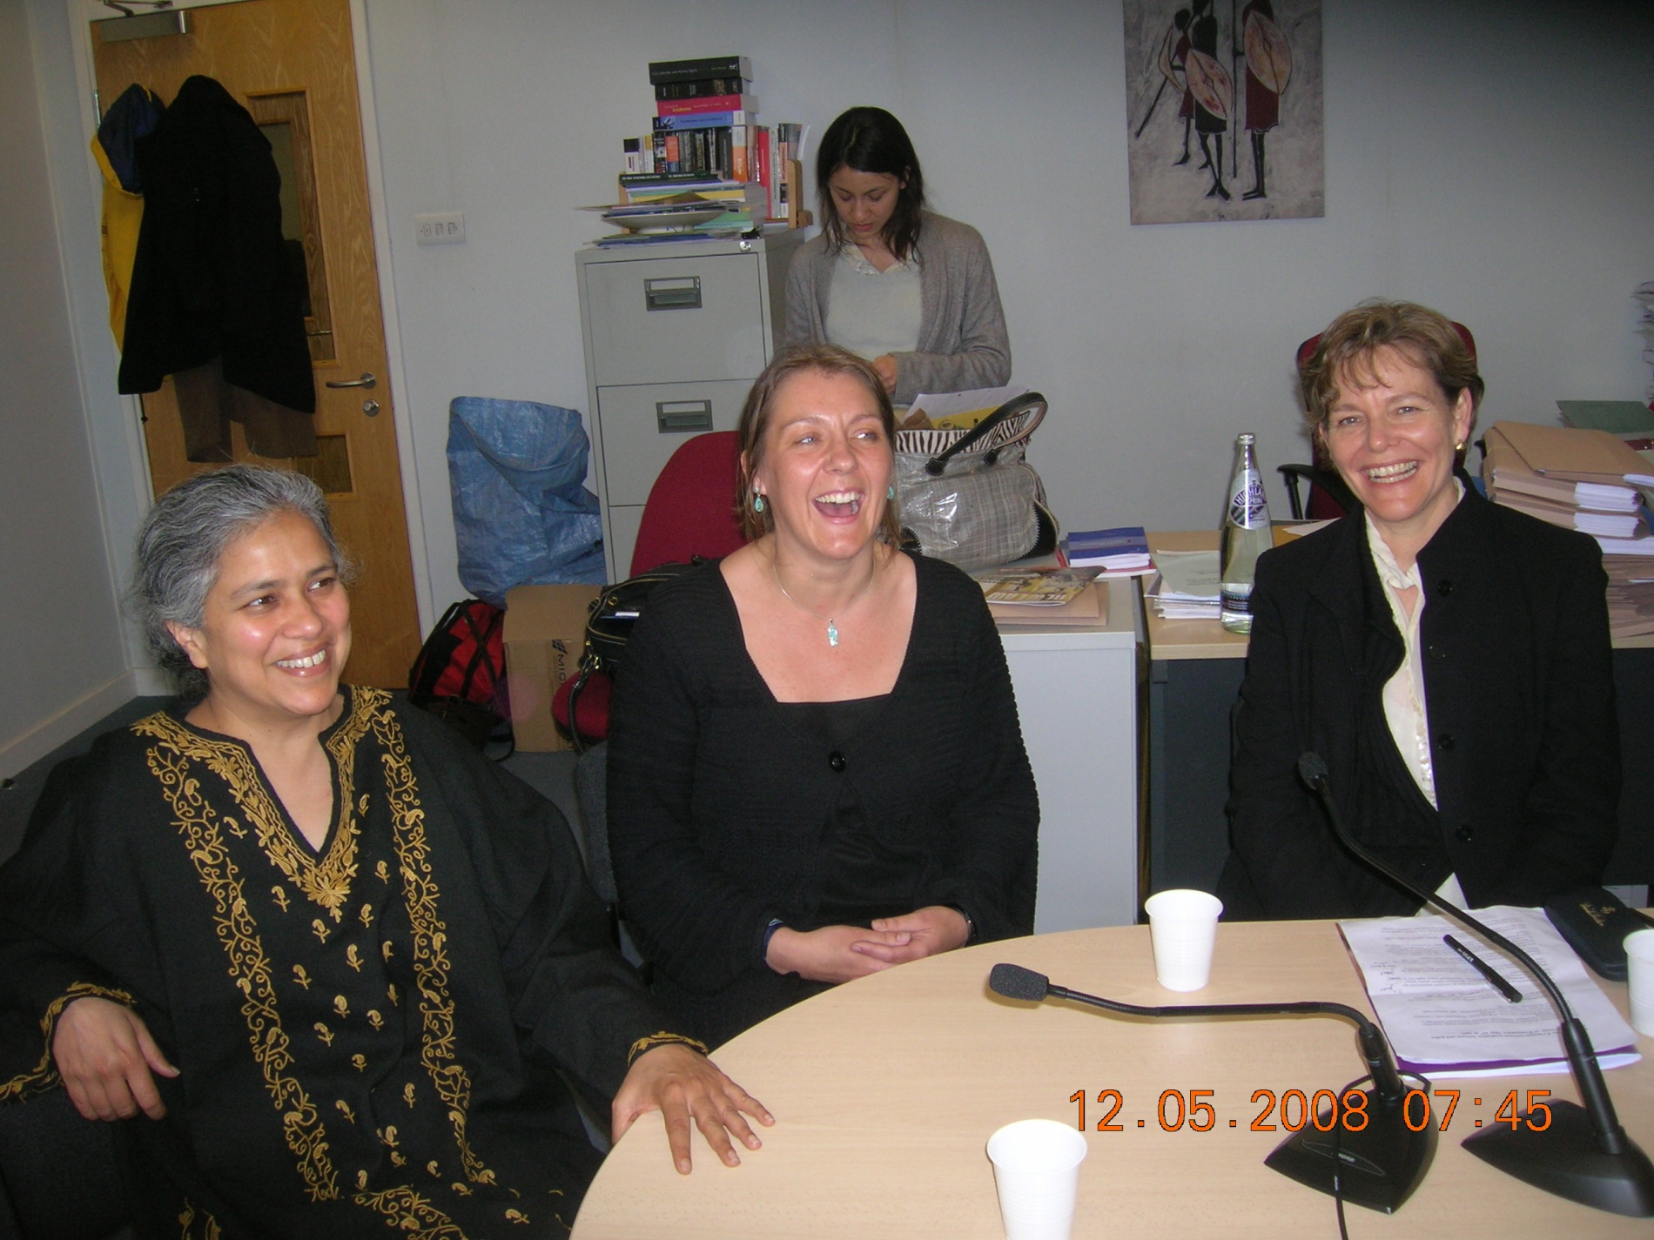
Gita Sahgal, Kathryn Lockett and Professor Hilary Charlesworth relaxing after the conversation!

