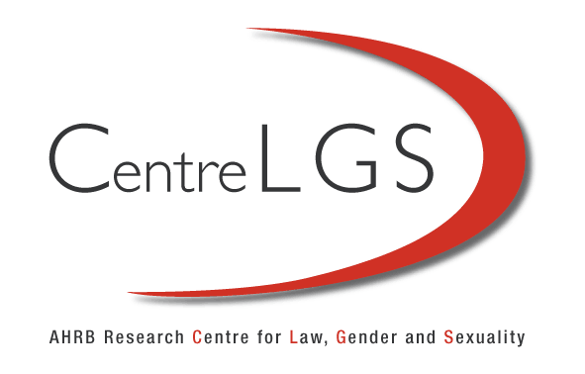

Conversations:
Exchanges between academics, activists and policy makers
Centre for Law, Gender and Sexuality
University of Westminster
27th April 2010
SEX, GENDER AND RELIGION

The Panel –
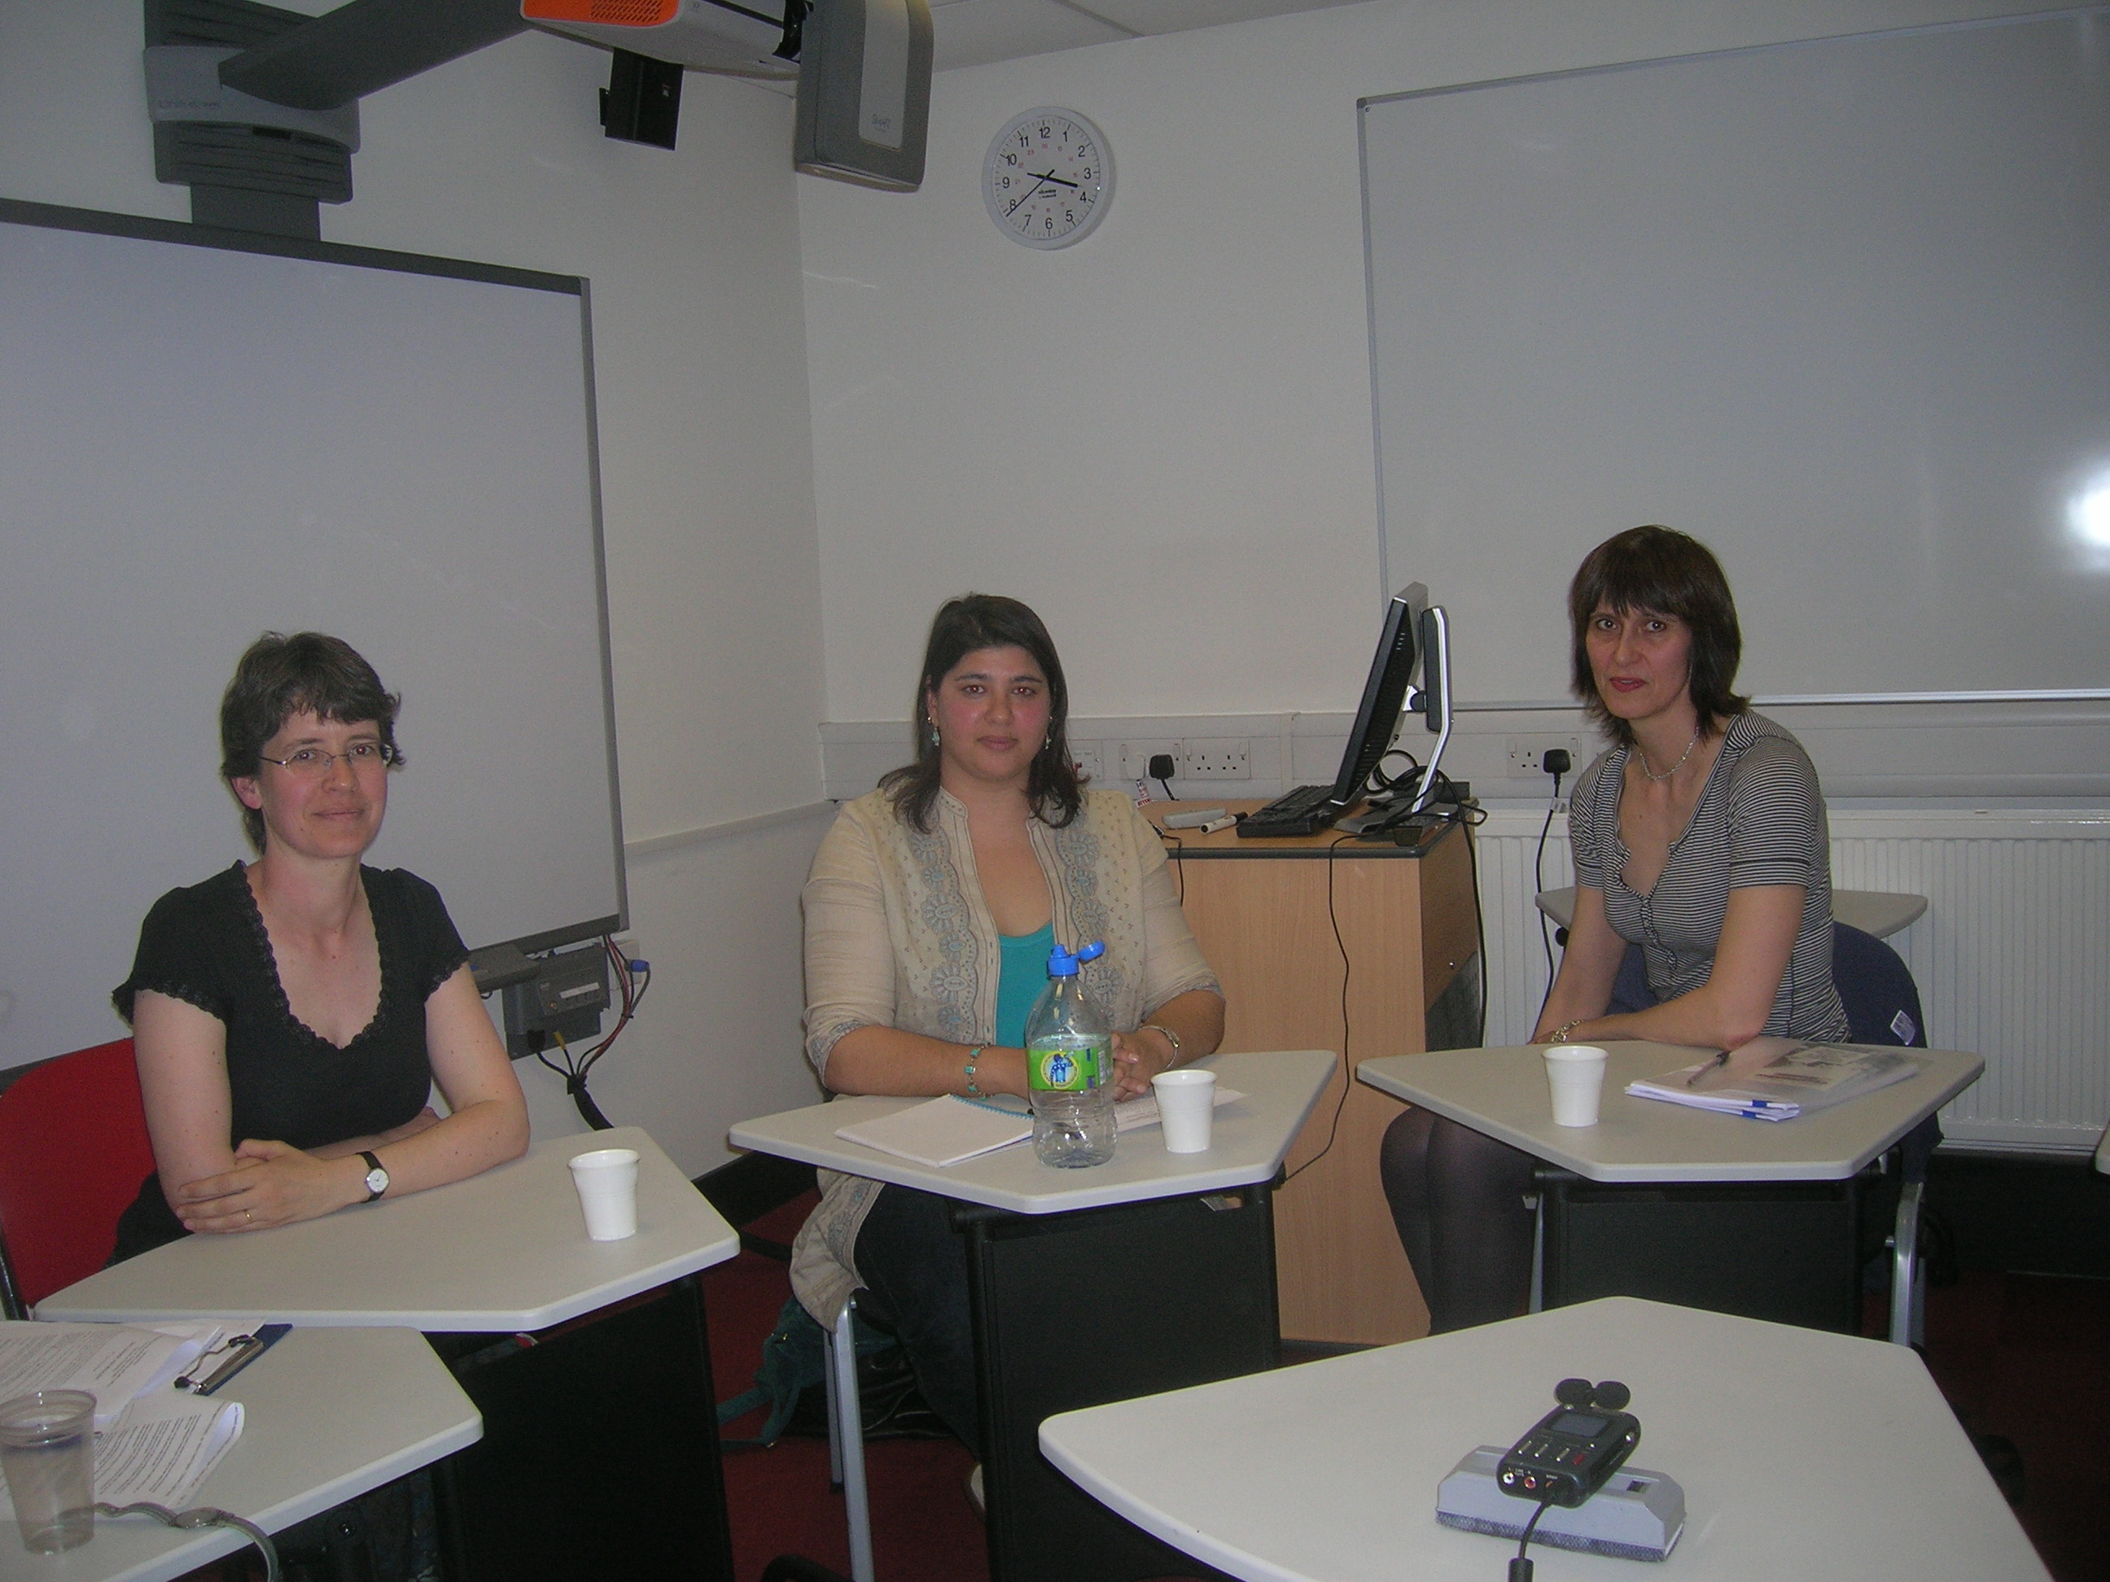
Dr Lucy Vickers, Suhraiya Jivraj and Tessa Kendall

Dr Lucy Vickers is Professor of Law at Oxford Brookes University. She writes on the protection of human rights at work and has most recently focused on religious freedom in the workplace.
Suhraiya Jivraj is lecturer in law at Oxford Brookes. Her research interests include the circulation of religion in society. She is also a founder member of the Safra Project, an organisation that works with and on behalf of lesbian, bisexual and transgender Muslim women.
Tessa Kendall works for the National Secular Society, and campaigns for a society that does not discriminate or afford privilege on the basis of religious belief or lack thereof.
Elizabeth O’Casey is a council member for the NSS and focuses particularly on international issues. She is also a PhD research candidate at the LSE. Her research interests include international ethics, universal needs and values.
Harriet Samuels is Reader in Law at the University of Westminster. Her research interests include human rights with specific reference to women.

How can law and religion be mapped out and can this be used to explore the nexus between sex, gender and religion?
When Tony Blair was asked in an interview about his Christian faith, Alistair Campbell famously interjected with, ‘We don’t do God’. Is there a place for religious conviction in public life?
Does the law, for example in the Equality Act restrict the freedom of religion to act in accordance with faith?
Are people’s religious beliefs restricted by the law, and more broadly what is the role of the law in regulating religious belief, especially manifestations of religious beliefs in the workplace?
What is the role of religion in education?
Is there a role for law in the regulation of religious belief?
Is a rights based approach the best way to address gender, sexuality and religion?
How far does gender and sexuality determine the construction of religious experience particularly in relation to women?
How does religious experience construct women, and what’s women’s role within religion?
What is the role of activists and policy makers in further understanding the complexities of religion and religious rites?
HS - Is there a role for religious conviction in public life?
TK - It depends what you mean by ‘in public life’. You carry your beliefs with you whatever they are. What we’re interested in is not so much in what you believe as what you do – it’s your actions and whether you’re demanding privilege or whether your discriminating against people on the basis of your religion, in public life, that’s what we campaign against.
LV - The other issue is that while it may be up to individuals to act on beliefs as they see fit, often that question about the role of religion in public life is to do with the role of organised religious group and one of the difficulties there is that religious freedom has a collective dimension to it and therefore the question is at what point those groups have a right to speak as a group, on the public stage. This is particularly problematic because many of those groups will seek to speak for everybody of that religious faith and silence the voices of those who disagree with them.
TK - It is generally men speaking, as well, for the whole. They tend to see their flock as a homogenous group and they’re not always.
EO - I find group rights slightly dubious in terms of their potential to exclude individuals. I don’t see why we should give groups themselves rights, instead we should be concerned with the individual.
LV - I’d agree with that but I think that the difficulty can be that those individual members of the group may have some associational rights – the freedom of association exists independently of the freedom of religion. People do have a right to meet together and do as they wish in their group. The question in terms of the role of religion in public life is whether that group has an additional, almost personalised right to operate and at that point I think it becomes problematic.
EO - For me, a religious identity might affect how you vote in an election but that logic doesn’t extend to that group itself having a specific voting right, or a specific right within government practice. I know it’s contentious – we have workers rights through unions which do have lobbying powers but to me group rights are slightly incoherent, it’s a misuse of rights.
TK- It depends on what those rights are. For example if you’re looking at the right of the established church to run a third of schools in this country and to lay down the law about what’s taught in those schools, about sex education, sometimes about science, is it their right necessarily, because they have a right of association, a right to believe that, that they can then control what’s taught? So it’s very complex.
SJ - I would agree with everything that’s been said, particularly about group rights. I think though, that when religion comes up as an issue, particularly in law, the focus is on issues of group rights and religious organisations and religious bodies. A major element of how religion operates that gets ignored is what was said earlier about how everyone has their beliefs whether they’re religious or not and in this sense the issue is how religion permeates in ways that aren’t identifiable, but still has effects in terms of individual subjectivity but then coming together in terms of how that actually influences policy. How do you indentify what is secular and what isn’t? Where do we draw the line? Some things are clearer but religion does operate and circulate in ways that are much more subtle so it does become quite difficult in terms of saying ‘this is a religious conviction, this is not’.
TK - But part of the problem is that often people of no religion get left out. It’s assumed that morality comes from religion.
SJ- I think in practice you’re right. I think that we do have to make more effort at looking at what religion means in each circumstance, rather than focusing the kind of debates. I think controversies can be misplaced because they’re around a very particular idea of what religion is rather than looking at the real complexities.
LV - And one further complication of that, coming back to this idea of individual rights vs. collective rights is that our whole idea of religion can tend to be very much to do with personal beliefs and therefore it’s based on an individual right and these collectives don’t have any role. This has actually been argued to be a very Protestant version of what a religion is, and the whole idea of what religion is, is a lot more complex than just purely something based on what people believe.
HS – Does the law, for example in the Equality Act restrict the freedom of religion to act in accordance with faith and more broadly what is the role of the law in regulating religious belief, especially manifestations of religious beliefs in the workplace?
TK - One thing that we’ve been particularly interested in is people claiming the right to wear some kind of religious insignia at work, and when you look at these cases, often if you’ve signed a contract to do a job, where there are uniform policies and there are health and safety matters. And in that case, I think there does need to be a hierarchy, there need to be safety and health of people first.
LV - I think if it’s as extreme a case as people’s lives at risk then the law is very clear – you don’t have a right, none of the cases have been successful on those grounds
TK – No, but what’s happening now is that more claims are being made, usually with the Christian Legal Centre behind them. And when they fail, people just claim, ‘Oh religious persecution, we’re being persecuted’.
LV - I think we need to be careful about providing laws because we’re being driven by an agenda run by the media. We need a sense of proportion about whether or not these cases are winning.
I think in terms of the role of religion in the workplace, the ECHR case law does make very clear that you have a right to manifest your religion but you don’t have a right to a job. If we set that as our only protection for religion you don’t actually have equality – some Muslim women and Sikh men are disadvantaged. So there’s always a question of trying to get some sort of a balance between the rights of those people to have access to work and the equality rights in relation to religion. And the way the law does it is to introduce the concept of proportionality which is about making a balance in each case. The difficulty is that proportionality arguments needs to be very subtle and quite nuanced and people want a blanket rule.
EO – On a secular level and as a secular issue, one concern I do have is priority or privilege to people just because they say they’ve got religious belief.
TK - I think also we need to look at conscience clauses in the workplace as well. For example there have been reports recently about pharmacists refusing to sell emergency contraception because it’s against their beliefs
LV – I think there is a gap between what the law says and what is sometimes happening – and it is the law that is attacked as at fault. So I think one of the issues in the proportionality equation that we need to look at is the reality on the ground in these cases – so: ‘does this restriction on somebody wearing a headscarf at work mean that they can’t get a job anywhere’ – if all workplaces start to ban it, that therefore interferes with the right of a significant number of women to work. That’s actually quite a disproportionate impact.
TK - I think these blanket guidelines disadvantage both ways.
LV - Yes so I think there’s a real issue of learning to live with the complexity involved. And the media often wants a quick answer, which will always be ‘no’ because nobody’s going to want to agree that in all circumstances, at all times you have a right. What might be allowed is a sense of ‘where proportionate’ but that immediately makes things much fuzzier.
TK - But I think also, the way that some religious leaders have been saying that equality laws are disadvantaging them, that they prevent them from following their religion. But often when you pick the argument apart it doesn’t stand. There’s a slight problem with people wanting to pick and choose the laws that suit their prejudices.
LV – And an issue that the courts do struggle with from time to time, is whether or not what’s required of their faith and what’s just something that you like to do. That’s quite different from the rules, to do with the employment for the purpose of an organised religion of somebody to carry out religious rite, which have been equally attacked but where the issues are quite different. Not all members of the religious group may agree but there’s a very big difference between the law allowing an exception to a key aspect of religious practice, and allowing an exception to a group who want to provide a service.
SJ - I think again, and this comes back to the issue of what do we mean by religion. And I don’t tend to be particularly easy on the law but I think with all this legal change that’s fairly recent and fairly extensive in terms of the context that we’ve been coming from, it’s inevitable that there’s going to be a kind of extra-sensitivity on all sides and initial teething and implementation problems. So I’d rather focus on that, rather criticising the law for not working, because we’ve only had a few cases. But I also think that these cases and the media attention struggle to get to the real gritty, dirty, harassing, suffering circumstances that people live with on a day to day basis. Why are we not talking about socio-economic disadvantage, poverty and deprivation linked to a whole host of factors including class but also religion and race and all the rest of it? These complex intersectional identities all need to be looked at, but the law can only do so much and the attention never really gets focused on this other stuff.
TK - I think that part of the problem is that politicians listen to the ones that shout the loudest. And these problems aren’t very sexy issues when you’re trying to get re-elected.
LV - But just in terms of the legal cases that have been referred to, it is interesting in terms of the rhetoric that’s thrown at the law in terms of it being inadequate which is that all of those religious claims, they’ve pretty much all failed. Which never gets reported.
EO - I still don’t think that citing the law and the losses addresses the issue of religious belief and the privilege in terms of a belief that might be a plausible way to get exemption. The cases weren’t won, but I still think in society we have a perception of religious belief being so entwined in your identity that religious belief is actually made analogous in the equality bill to race, disability, sexual orientation and gender, all of which to me are different – they are something you haven’t decided.
LV - Would you say the same for lack of religion?
EO - Yes, absolutely. It’s all a choice. However I would point out that lack of religion is a neutral state in term of we’re not born believing in anything so whereas lack of religion is neutral, religion is a positive.
LV - But that doesn’t really reflect the lived reality for a huge number of people. So people don’t get born with nothing and then make a choice, because they are brought up within families that then teach them something and very few of those people choose to change it.
EO - That’s a cultural thing and that’s something I’d not want to address in legislation.
TK – For lot of these people, belief is kind of vestigial isn’t it? They may put Christian down on the census but it’s just because they have some vague cultural or ‘I was brought up that way’.
EO - And the danger is when I criticise, or when anyone criticises Islam, or Christianity, that it’s racist. It’s nothing to do with race. Discriminating against people because of their race is very different to criticising religion.
SJ - I think it’s going down quite a slippery slope when people start saying ‘this is racist, that is not racist’. It’s like beauty; it’s in the eye of the beholder or the experience of that particular person.
Again I come back to that kind of position of complex individual identity. The majority of Muslims will be non-white in this country: when people see you or acknowledge you, it will be not just as Muslim, but that will be infused with kind of racial overtones and drawing the line between Islamophobia or prejudice based on religion and racism is extremely difficult and complex. We must try to understand that reacting in a rational manner does come from being privileged, from having space to be able to be free of prejudice and economic disadvantage linked to their lived situation. And there’s plenty of research that shows this reaction, a defensive reaction of ‘you’re being racist towards me’ or ‘you’re being Islamophobic’ as a reaction that comes from a very complex situation. And I’m not saying that all of the defensive reactions are infused by that, and certainly the kind of religious bodies, they have their own political agendas, but I’m talking about the ordinary person and you cannot ignore the fact that Muslims are under hyper-surveillance. We really must give people, whatever their situation, some space to understand the complexity of the opposition of their standpoint and try and grapple with that rather than say, ‘you can’t just call me racist because I’m defending freedom of speech or I’m defending a secular value as it were’. And a lot of these people probably are secular, that’s the irony of it, but it’s the messiness of the situation that really needs to be unpacked before we can come to a conversation point where we can think about how we move forward more productively I guess.
LV – In terms of the issue of privilege I think the other perspective on that is that you have to look at where people are starting from. And if you experience the level of disadvantage on a day to day basis that Suhraiya’s talking about, giving a concession that says, ‘we will recognise that is extremely important to you, to be able to have your photograph taken with that, given that that’s what you wear all the time and when they are trying to assess whether it’s you or not’ that’s a relatively small concession.
EO - And in the realities that you’ve painted today, that all makes sense, but to me in a true secular society there would be no discrimination from profiling.
HS – In terms of this debate about privileging, what should the role of religion be in education?
TK - Our position on that really is that publicly funded schools should be equally open to everybody, they shouldn’t be discriminating who they take in or who they hire. If someone wants to run a privately funded school that’s up to them. If it’s public money, its public space therefore everyone should get the same chance. And the law should uphold that.
LV - We have a historical problem which was when we introduced universal free education, there weren’t enough schools and the state had to do a deal with the churches. And we’re still living with the consequences of that. And it seems to me that the situation’s become polarised significantly in recent years.
TK - Rowan Williams has said a church school is a church.
LV - It moved from, ‘this is a service we offer to the community’ to ‘this is our outreach to the population. I think that if the churches are to retain a role because the state can’t afford to buy the buildings, then I would be much more comfortable with it being more nominal. And ideally, if they had the money, they’d buy the churches out. But in the meantime, I think that the way to achieve that equality is to remove the School Standards and Frameworks Act, which is the legislation that allows schools to discriminate.
EO - I would offer ethics as well, instead of RE.
TK - There’s a difference between teaching children about religion, because they live in a society where there is religion and they should learn about all of them.
LV – The problem is that we don’t necessarily teach religion very well – it’s just presented as sets of ceremonies and customs. Although some would argue that these ceremonies and customs are central to some religion so even that debate about how we teach religion and what it actually means to teach religion and RE brings out these differences between what we actually mean by religion in the first place. And the other problem I feel, with the Children, Schools and Families Bill was that even if you leave aside the whole debate about sexual orientation, there was a very strong emphasis that everyone was going to be taught about the value of marriage – or civil partnership. But why this focus on such a particular ethical view – that this is the way our children should be brought up.
EO - There’s almost an implicit assumption that sex or having children outside civil partnership and marriage is wrong which is very dubious.
TK - It talks a lot about the importance of spirituality, the importance of religion in the context of sex and your sexual identity, your gender and all of that. But that’s not for everybody. There are a lot of people who have no belief and their perfectly capable of being moral. If you tell them the facts, they will make the decisions on their own actions, and you must tell them they should take responsibility for what they do.
LV - But also, the implication that we need to be teaching sex education within any moral framework is an interesting one because it immediately raises the question of what is that moral framework?
EO - Surely it should be in the context of science.
L V - So neutral with regards this?
TK –Yes and the fact that actions have consequences and what can be done in the face of these consequences.
HS - What is the value of using a rights based approach and about the idea of rights as trumps that outdo other values?
LV - I don’t think that even if we use rights talk then that means that rights trump, all rights, as I’ve already said are mostly subject to ‘where appropriate and where proportionate’ and they can be restricted in pursuance of a legitimate aim. Rights should be a basis for a conversation - I think it’s a useful language but we need to be careful how we use it.
EO - I think there are certain rights that do trump. The right to equality – to equal treatment, the right to freedom of speech, the right to life. And some socio-economic rights, or perhaps duties.
LV - I’m quite happy to say that the right to equality should trump but the difficulty is as soon as you get beyond the rhetoric of that, we run into difficulties about which equalities, on which grounds and how does systemic disadvantage influence here? The devil is in the detail.
TK - I think the problem is where giving someone what you might call equality puts someone else at a serious disadvantage.
LV - And I think that allowing Muslim women to wear a headscarf in most situations doesn’t disadvantage anybody. There is of course a slippery slope where if you allow everybody to wear everything then where do you draw some lines. And therefore they’ve drawn those lines around identifiable groups who have some stronger rather than a personal one.
EO - I think the problem always takes us back to the same issue about identity and how intrinsic it is to you and whether it’s a choice. And if you don’t see it as a choice then it seems to me to be perfectly reasonable that accommodations should be made. But if you do see it as a choice and it’s costing money and costing time and costing resources, then one starts to question whether it’s worth it. And that’s one of the most crucial questions about how much of a decision it is.
LV – There’s also an issue about when we look at choice, about levels of choice and about how fundamental it is - choices that are not acceptable to expect people to have to make.
EO – But dealing with things on a case by case basis or accommodating people here and there will never really deal with the issue, it will keep causing problems and disagreement.
SJ - I think that it’s a product of the history of our legal system, the fact that our legal system is one that evolves and it is very different to other jurisdictions. I think having this flexibility does have its downsides but I still prefer that, because if you have a strong civil society, there is space for that to be lobbied and critiqued by academics and it is a discursive terrain.
HS – How far does gender and sexuality determine the construction of religious experience perhaps particularly in relation to women, so how does religious experience construct women, and what’s women’s role within religion?
SJ – I think it’s difficult to generalise, but in terms of patriarchy, I think what needs to be done is look at, and pay more attention to the amazing reformist work that is being done, by women within religions and the changes that they are bringing about. They need publicity, and they need more funding.
TK - The flip side of that is that there are bad things happening to women within religion that are just being hidden. I’ve been doing some work recently on the abuse of women by clergy and it’s not spoken about it – it happens all the time but it’s kept quite.
HS - So the nature of the patriarchy – the patriarchal nature of religion is something that is problematic. It seems to be that the way that’s going to change, or hopefully going to change is, the controversial and difficult bit.
LV – I suppose it goes back to one group claiming to speak for all within their religion and holding too much power. And I think there’s a danger of using the law to force change rather than letting debates happen within groups. I think it’s better to give support to those groups within the churches, or within those religious groups to reach them.
EO – I think you need to try to balance leaving the group to do as it sees fit, but also make sure that everyone in the group is happy to be there.
SJ - I think there’s a real important issue around who are the gatekeepers of religious knowledge in terms of feeding in to government policy. This is changing, but the way that government and religion interact needs to be interrogated much more, especially if you’re coming from a feminist perspective.
HS – Finally, what do you think that the role of the academic or the activist or the policy maker is in regard to religion?
SJ – Coming from an activist background, I think having the time, space and resources to reflect is really important – having the means to really think about the complexities with which we engage.
LV – The academic role is to have the space and the time to do some deep thinking about this, which is not to say that nobody else is doing that. And if that can feed in to some of the activist agenda then that’s all to the good. So I would hope that conversations like that are useful in that sense.
TK – Campaigning on the ground we rely on academics giving us information. Our role is to question and challenge demands for privilege. and the more stuff we get from academics, the more information we get from them, the more we can do our job, so I see it very much as a partnership.
EO - I think that’s completely right, I think activists actually do something, but you run the risk of having inconsistencies and conflicts in what you do if you haven’t actually examined the principals or the foundations upon which it lies
TK - There is a role for both isn’t there? I think most of these contested issues will never be resolved, we’re never going to get the answer, there’s always going to be contest around that, but while we’re debating that, some action needs to be taken. It does need both. Certainly I think if you’re a thoughtful person, I think you want to look at the foundations of what you’re saying as much as you’ve got time to do.

