SUBMISSION TO IPPR LONDON HOUSING COMMISSION FROM HIGHBURY GROUP ON HOUSING DELIVERY
Introduction
The Highbury Group is an independent group of specialists from public, private and independent sectors from housing, planning and related professions which prepares proposals for Government and other agencies on policy options for optimising the output of housing including affordable housing. The current membership is set out in a footnote to this submission
The group welcomes the establishment of the London Housing Commission by the IPPR. While the Highbury Group is a national network, many of the group’s members have extensive experience of housing and planning in London and the Greater Southeast.
Our submission focuses on the specific questions in your call for evidence. We would however wish to make some broader points. The focus of your questions is on increasing overall housing supply. We would put much more focus on the type of housing supply, in terms of location, built form, quality, mix and size (including family size homes) and critically the affordability of supply to households on middle and lower incomes. We need strong and enforceable targets for housing affordable by lower income households without dependence on high levels of housing benefit. This requires a programme of social rented housing at target rents, funded primarily by Government capital grant. We also need strong and enforceable targets for the mix of housing provision both across London and on individual sites to ensure that we provide to meet the full range of housing needs, contrasting with the current development programme which is disproportionately focused on small flats. We are therefore strongly opposed to the recent Government announcement that planning policies in relation to affordable housing are to be significantly weakened. We need to recognise that to meet a wider range of housing needs, we cannot continue with the current focus on developing high density and hyperdense schemes in central London and the Mayor’s Opportunity Areas, but ned to have a much more dispersed programme of development including town centre intensification, infill development in lower density residential suburbs, and urban extensions to London and the Home Counties towns, which may include some planned development within the Green Belt. The Group does not see the densification of existing council estates through demolition, displacement and redevelopment as the most appropriate response to the identified housing deficit and is concerned that such an approach further reduces the supply of affordable housing in London.
We also do not support an over-reliance on increased investment in the private rented sector. We welcome the provision of new privately rented accommodation, where it provides good quality housing affordable by lower and middle income households within a framework of regulation, rent control and an appropriate level of security of tenure, we do not anticipate that private rented provision can in itself replace the need both to maintain the existing supply of council and housing association social rented homes and a substantial programme of new social rented provision.
We also consider that greater attention should be given to the need to bring land forward for development at existing use value and for the public sector to benefit from value uplift, rather than the gain being realised solely by landowners and developers. This requires significant changes in the current arrangements for compulsory purchase. We also argue for a substantial reform of property and land taxation to ensure that taxation policy generates a more efficient use of both the existing housing stock and new housing supply.
We would also draw your attention to the statement on housing supply published by the Highbury Group before the General Election which expands on some of these key points.

Part 1 How can we double the delivery of homes in London every year and maintain high levels of housing delivery in the long term?
a) What are the core barriers to high delivery rates?
The primary obstacle to private sector led housing development is neither the availability of land nor the operation of the planning system. The development capacity of the house-builder sector is limited and major developers do not support a significant increase in housing output or build out rates of consented schemes as this could reduce their returns as it is in the interest of developers to limit output to ensure competitive demand and maximise sale price. The cost of land and lack of transport and social infrastructure can delay the build out of schemes, as these limit market price. This explains why major schemes have been slow to progress, either because developers paid too much for the land (especially before the 2008 recession for central London sites) or because major infrastructure is required (generally in the case of more peripheral sites such as the outer Docklands area). Given the limit on developer capacity, the absence of both direct and indirect subsidy limits both the development of sub-market housing and overall output. The increasing cost of labour and shortage of materials are also factors. It should however be stressed that the focus of policy interventions should not just be on increasing numerical output, but on ensuring appropriate homes are provided for a range of household types, tenures and incomes in sustainable locations which meet social, economic and social sustainability criteria, to meet the full range of housing requirements. The programme should focus on homes for occupation rather than on assets for investment. The private sector is not capable of doubling overall housing output or providing more homes affordable to lower and middle income households without significant direct or indirect financial support. Consequently in order to achieve London’s housing needs target of 62,000 new homes a year, of which over 50% need to be at prices or rents significantly below market levels, public sector intervention, including direct development by local authorities and social housing agencies, is required.
b) What are the key planning powers needed to ensure that targets are met?
Local planning authorities should set borough wide and site specific targets for housing which meets the full range of housing requirements. Schemes which do not meet these criteria should not be given planning approval. Boroughs should have the power to zone sites for specific types of housing provision and, where necessary, to acquire the sites compulsorily at the pre-existing use value. They should then either develop the sites directly or transfer the land to developers and/or housing associations for development which meets the planning brief for the site.
And should these instruments be held by the government, the London Mayor, London boroughs or some other body?
The Borough should have the duty to determine planning briefs for appropriate sites. Both the Mayor and the Borough should have compulsory acquisition powers. The Secretary of State should have the positive power to intervene where neither the Mayor nor the Borough is meeting its requirement based targets, but should not have a negative power.
c) How can the land market be reformed to increase output? What role should public land, greenfield, new towns, garden cities and estate regeneration play in providing enough land for target levels of house-building ?
The land market would operate more effectively where site values were determined by planning policy and where the Mayor and boroughs had CPO powers as described above.
Given the shortage of housing output, a range of development options are required, including development of appropriate brownfield sites (while ensuring retention of employment capacity), town centre residential development incremental suburban residential intensification, appropriate urban extensions both on the edge of London and at the edge of county towns, where necessary incorporating land designated as Green Belt which does not significantly contribute to Green Belt objectives. Major new settlements outside London may contribute to housing output where development is sustainable, where residents have access to employment opportunities and where supported by public transport. Council estates should only be redeveloped where existing housing stock is unfit and not capable of cost-effective rehabilitation, where existing residents are protected, and where densification does not lead to overdevelopment or inappropriate forms of housing output relative to assessed housing requirements. There should be no net loss of social rented housing through estate redevelopment. A policy of focusing development output on hyperdense and high density schemes to maximise numerical output with no regard for whether the development is making a significant contribution to meeting London’s housing requirements is not appropriate.
It is important to recognise that the London travel to work area and therefore the London centred housing market extends well beyond the Greater London administrative boundary. It is essential that development capacity across the wider London metropolitan region is used effectively. This is critical if we are to deliver the range of housing types needed accessible by households on a range of household incomes. Assessments of housing requirements and development capacity need to be undertaken on a consistent basis across London and the Home Counties and a strategic planning mechanism and governance structure that ensures the most appropriate use of development capacity across the metropolitan region.
d) What changes in the development and construction industries are needed to increase the speed and scale of supply?
A wider range of housing providers is required to challenge the dominance of a small number of house-builders. Larger sites need to be divided between a number of developers and this process is best managed by the local authority. The land tax regimes should incentivise the bringing forward of appropriate sites for development and dis-incentivise trading in land and planning consents. Public funding should be made available to small and medium sized housing associations and cooperatives to build small scale social rented schemes. Government should ensure an adequate supply of building materials and skilled labour through training and apprenticeships.
e) How are the current range of demand side measures (such as Help to Buy) performing in the capital?
The Government should cancel all initiatives which increase effective demand rather than increasing supply, such as Help to Buy. Such initiatives only increase house prices and in the longer term exclude more households from the housing market. Government funds should not be used to support individual house purchase, as this in effect subsidising selected households to achieve individual wealth appreciation. The option of replacing stamp duty on property purchase by a capital gains tax on property disposal should be considered with a full study of potential impact on house-prices, affordability and on potential revenue being undertaken before implementation. Receipts should be ring-fenced to support investment in new social rented housing and supporting social infrastructure.
f) How are the current range of supply side policies performing in the capital? What changes need to be made in order to build the required number of home?
There does not appear to be any coherent Government supply side strategy. The programme of funding housing associations and councils to provide social rented homes should be reinstated. Moreover, all policies which lead to existing homes becoming less affordable, such as council house sales and converting social rented homes to sub-market rented homes should be terminated.

g) How can the tax system support more housing development?
In addition to consideration of the proposal above to replace stamp duty with a capital gains tax, taxes need to incentivise effective occupation of housing. Penal rates of taxation should be applied to vacant properties and to second homes. Council tax should be revised to include higher rates of tax for higher value property (on a sliding scale rather than a banding system). The option of introducing a tax supplement for those under-occupying properties could be considered as this would incentivise downsizing. It is however recognised that this raises both administrative and political issues. Where an owner has insufficient income to pay such a tax, the tax could be deferred until vacation. Inheritance tax should be amended to limit the transfer of property related wealth between generations. This will remove the housing market advantage held by those who have wealthy parents, and should lead to an overall reduction in average house-prices. Receipts from the new taxes should be used to support investment in social rented housing for those who cannot access market housing. A comprehensive review of property and land tax reform options appropriate to the London context, building on the IFS Mirlees report, could also include consideration of the reintroduction of schedule A into the income tax system., that is tax on the imputed rental value of owner occupied property. It is important to recognise that the London housing context is exceptional and that tax measures appropriate in the London context may not be appropriate in other parts of the country. Tax reforms are however necessary to support an effective housing strategy.
h) What policy changes would generate greater social sector housebuilding?
As proposed above, the Government programme of capital investment in social rented provision should be reinstated to meet the housing requirement. This was estimated by the last Mayor of London Strategic Housing Market Assessment as 35,320 per year (on the basis of meeting the backlog of housing need over 10 years). This assessment needs updating both to reflect actual and projected population growth and the reduced affordability of market home ownership and rental sectors since 2013, with the investment programme increased further to meet any increase in the assessed need. Capital subsidy to shared ownership homes and rented homes which are only marginally sub-market should be terminated. The definition of affordable housing in planning policy should be amended to ‘housing costs, including rents and service charges, which are no greater than 30% of the average net income of households with the lowest quartile of household incomes. Only schemes which meet these criteria should be given planning consent as affordable homes.

Part 2 How can we reconnect the costs of home ownership and renting to incomes in London?

a. What are the key factors driving up house prices in the capital, and what measures are needed to counter them?
London house prices (and PRS rents) are a consequence of the spending power of London’s upper 70% of households. Spending power on housing includes wealth from previous housing equity and material financial wealth for the top deciles. The chart below shows how London household incomes relate to house prices, excluding the sub-market sectors.

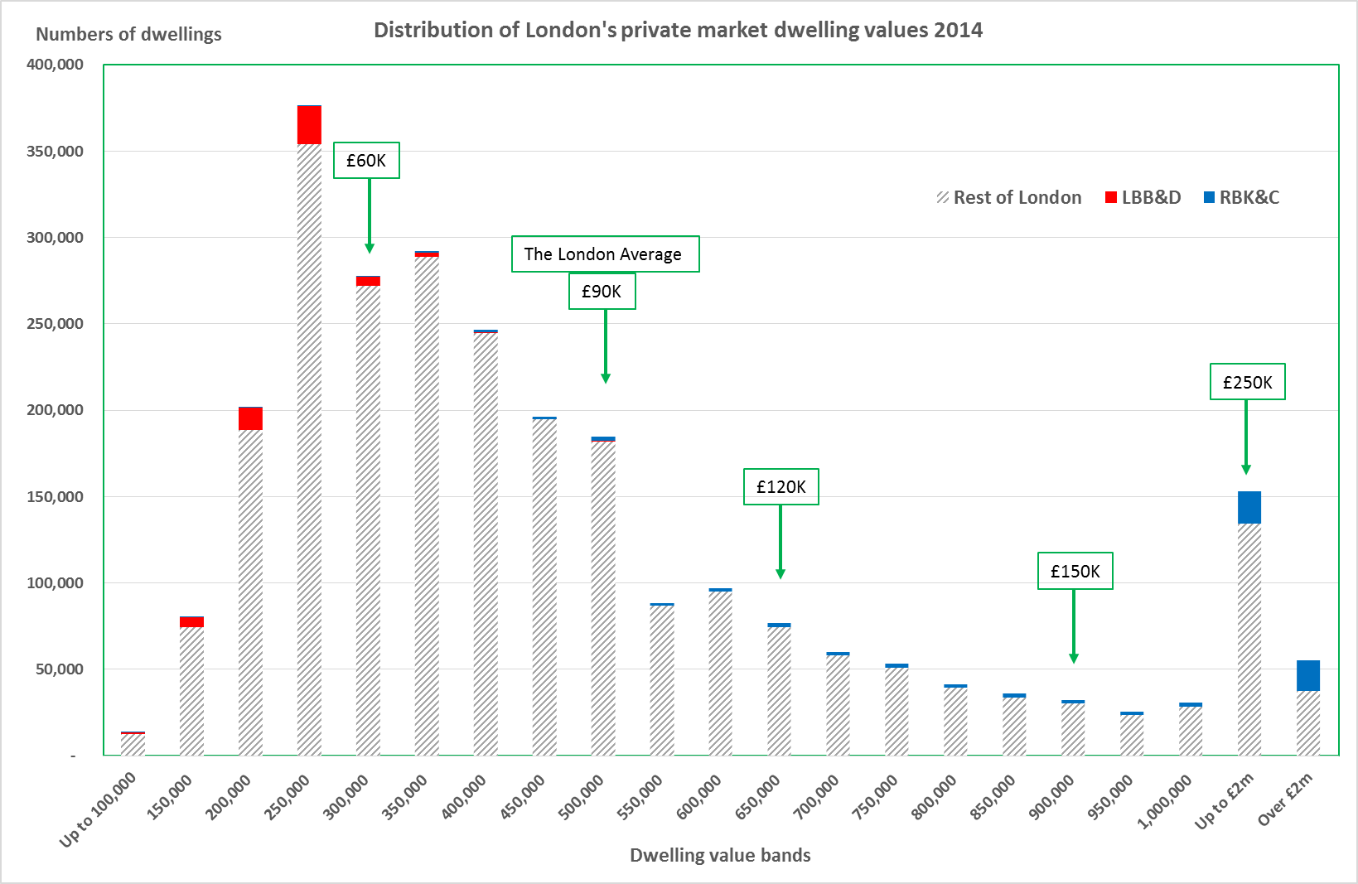
Average gross household income at purchase
£40K

The distribution of London’s incomes and wealth in the private housing sector is almost directly reflected in the distribution and level of London’s market house prices.

Supply imbalances have very small effects on price of stock occupied. London’s housing stock of dwellings has kept ahead of the number of households since the crude post-war shortage was eliminated in the mid-1970s. But in recent years the balance has tightened:

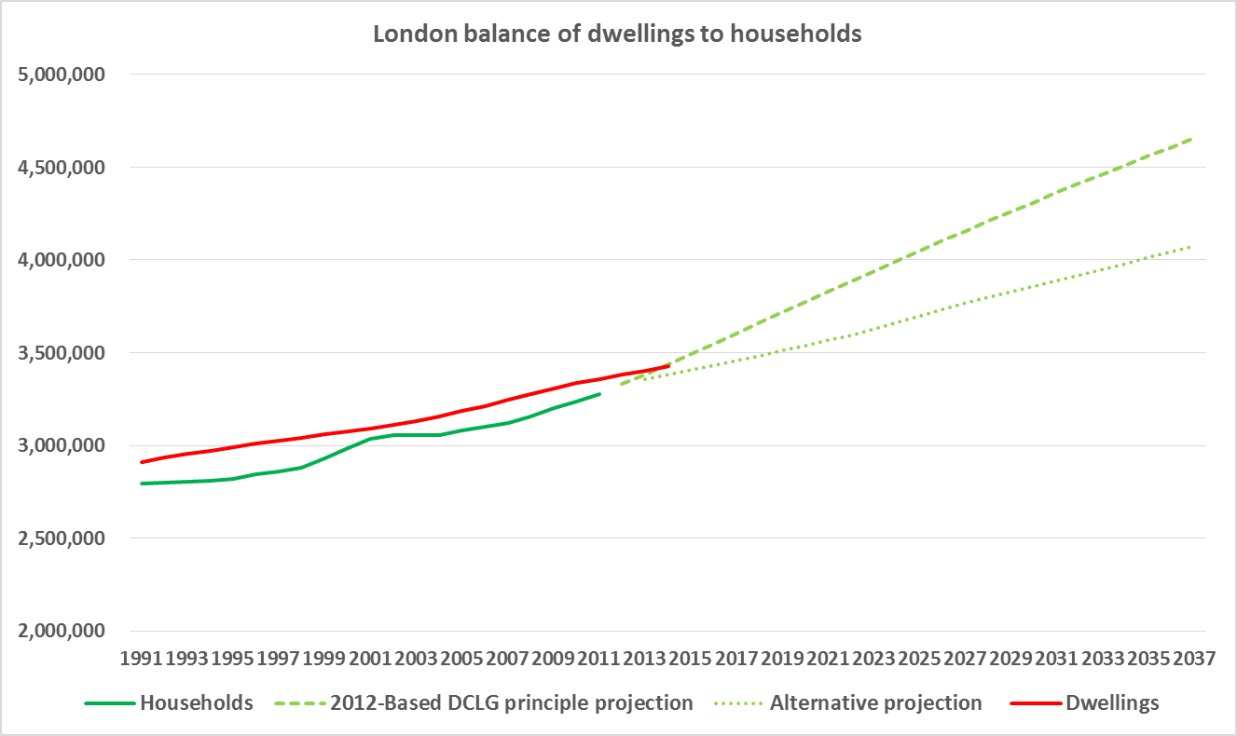

The DCLG principal projection would imply the need for growth in stock of more than 50,000 dwellings a year for the next ten years. The alternative projection based on stable household sizes, and population growth in line with the nation, would imply more than 30,000. The Mayor’s target of 42,000 supply, less say 4,000 losses, is at the lower end of the range. In the last decade we have averaged 24,000 net additions.

If we delivered 35,000 more than in the past, for the next ten years, then, using the econometric modelling of the Barker review this 1% extra stock pa would reduce house prices by 1.3% pa. In other words the inflated average house price in ten years’ time would be £750,000 rather than £850,000 ie 15% lower. But as much of the extra stock will be occupied through more households moving into London, and/or more staying longer, then this supply effect would be almost eliminated, and we would see higher vacancies and demolitions in the rest of the country (predominantly of the lower value public sector assets), and more second homes nationally.

The conclusion is that we should build primarily to meet the expected growing number of households, within a national policy, rather than to expect significant improvements in affordability within the private market. It would also be useful to monitor actual average floor space per person as a counter indicator to the partial endogeneity of households with dwellings.

House prices tend to rise faster than single average earnings growth rates. The Office for Budget Responsibility have revised their forecast methodology to use work by Professor Geoff Meen. Five year forecast: CPI = 2%pa, Earnings = 4.1%, House prices = 5.3%. This 1.3% “leverage” of HP to Earnings growth will reduce and may even fall below 1.0% in 10 to 20 years due to demographic, social and macroeconomic factors.

Reducing household spending power will reduce house prices but not change “affordability” in the general market, as both the effective income and costs reduce together. Taxation (of any kind) can help with redistribution of spending power but house prices in the market will also adjust, leaving the ratio of “affordability” much the same.

30% of London’s exiting households need help with their housing costs. 20% have no spending power at all on housing after basics (food, clothing, fuel, transport). For new households in housing need, the proportions are significantly higher.

Resources from taxation, and levies, improves affordability for those with little or no spending power on housing, through capital subsidy (affordable housing grant, S106) or revenue subsidy (housing benefit and welfare credits).

b. Are there new models of affordable housing that could work in London?

We need systems of subsidy for the 30% for rented housing. About 20% will never or be unlikely to be economically active (for example through age) and in this case a mix of capital and revenue subsidy is most efficient for the taxpayer; for the 10% (and many households move rapidly in and out of this bracket) who need partial assistance, a form of revenue subsidy is most efficient for the taxpayer.

The efficiency and effectiveness of both capital and revenue forms depends on flexible and responsive systems of support to adjust charges to the occupant as incomes rise and fall, and a corresponding systems of recycling subsidy. All occupants of sub-market publically subsidised housing should be regularly assessed through a revised Universal Credit system enabling social landlords to set an affordable rent for that household. We recommend that this is at 23% of gross household income (or 30% of net income) with a floor of “social rent” reflecting the grant already in the system and the need for a minimum rent to cover operating costs and the efficiencies achieved through private financing of part of the production cost. There is a case for variation according to household size. No rent set would be higher than the market rent for a dwelling. Accommodation in excess of need for the household size should be charged at the market rate, proportioned by numbers in the household/dwelling allowing for special needs (care, dialysis, etc), and with exceptions where no appropriate alternative supply is available in the locality.

There should be no subsidy for those able to buy or rent in the open market. Indeed there are risks that subsidy to marginal home owners (say on incomes above 80% of that required to buy in the lower HP deciles) are inflationary.

Shared Ownership has drifted up market to be a product for those in marginal home ownership. There is a case for a higher level of public sector investment so that rent on retained equity for a 40% share of ownership is affordable to those on household incomes between £25,000 and £40,000 per annum. The GLA, LA or other public sector body should retain an equity stake equivalent to the original subsidy, with any increased value repayable to the investor as a fixed proportion of value on resale. This would finance investment in further provision. There would also need to be strict controls to ensure that shared ownership was accessed only by households within the target income group.

c. How can the mayor maximise the impact of London’s share of Homes and Communities Agency (HCA) funding, and should this be linked to a rental model other than ‘affordable rent’?

The distribution of public subsidy between London and Rest of England is a matter for central government, within a national and regionally balanced economy, adjusted for local costs of provision. The current distribution is proportionally favourable to London; it is the total allocation to housing capital subsidy that has reduced nationally, and is below optimum.

The logic of the basic principle in the section b) above is that there should no longer be divisions into types of sub-market product (low rent social rent, affordable rent, intermediate market rent, rent on retained equity in shared ownership, etc). A graduated single system of capital subsidy (and hence rents) could apply across the low income spectrum. The new output (and adjustment of existing subsidised stock) should reflect household income distributions in the locality.

d. What role should the mortgage market play in constraining accommodation costs?

The mortgage market reacts to demand, and has done since the 1970s. We should encourage the principle of risk assessed interest rate, as strengthened by the Mortgage Market Review, e.g. higher rates of interest for higher LTV. We should extend this to discourage enticing low income households, who tend to have the most vulnerable incomes, into high LTV (85%+) purchases (including Shared Ownership).

e. How can the boroughs maximise affordable housing supply under s106 planning obligation agreements?

Simple ratios or quotas rarely work as the ability of each site to support infrastructure and affordable housing requirements will vary. Ultimately the result rests with the negotiating strength of the LPA, the economic capacity of the development, and the extent to which other public services (roads, schools, parks, etc.) are prioritised by the authority compared to affordable housing. In recent years we have seen a growing house builder lobby weakening the former, weak house buying demand in parts of London weakening the financial case (though in strong markets, where more subsidy for affordable housing is needed, the capacity is still there), and as illustrated by three consecutive DCLG research projects a trend for a growing proportion of obligations, by value, being for infrastructure other than affordable housing.

Any new development in London assisting less than 30% of the housing to be affordable (measured by the aggregate difference of price paid by the social landlord to the market value) should be deemed non-compliant with policy. The range of affordable housing “price points” should reflect the gap between district household income distributions and the amount (and rent levels) of existing sub-market supply.
We are concerned at the implications of the recent announcement by the Prime Minister to remove the ability of London boroughs to require through planning policy that developers provide a significant proportion of genuinely affordable housing either on site or off site. This would invalidate the planning policies operated by most if not all London boroughs, and have a significant negative impact on the supply of new affordable homes in London where need is most acute. Such a change of policy would stop boroughs from meeting housing needs in their local areas as required by current Government policy and guidance. The removal of such requirements will also increase land values and make it difficult for housing associations and other social housing developers to compete in the land market.

f. Beyond supply responses, how can we address the issue of rising rents?

Forms of rent control (beyond recourse to the Rent Assessment Committee to keep rents within market level) will adversely impact on new supply and investment in existing stock. Consequently, the need for public sector investment in rented provision will need to be increase should rent control be introduced. The issue of rent control is considered further in the next section.

g. What can be done to ensure that housing benefit continues to support people to live in every borough of London?
Housing benefit and welfare benefit limits should relate to the real costs of housing in the rental market. The group does not support caps which force lower income households out of central London and other higher value areas. It is important that lower income households whose members service much of London’s economy are able to live in central London in order to maintain London’s services and economic success. Displacing households to areas where housing costs are lower may force household members to increase expenditure on travelling to work. This leads to greater social polarisation and greater demands on London’s overstretched public transport system as well as causing significant disruption to the lives of families in relation to family networks, schooling and health provision. It is however important to ensure that households accessing social housing in higher value areas have a clear case for being resident in such an area for reasons of either employment or community networks.

Part 3 How can we provide a high quality private rented sector?

- How can we increase the volume of new-build private rented homes?

Most new residential development in London is carried out by a small number of large house builders. These developers follow a tested model of ‘drip feeding’ new housing onto the market, rather than releasing large chunks of stock at the same time. This is for three reasons: it helps cash flow (because income from the sale of early units helps finance the construction of later ones); it facilitates the sequencing of construction tasks; and it ensures that the market is not flooded with identical units, which would depress prices. Even on sites that will eventually accommodate thousands of homes, development for sale proceeds at a rate of a few hundred units a year at most.

The targeting of some blocks or sections of big sites for PRS use could help accelerate development, as policy makers have recognised. Producing entire blocks for sale to large landlords would allow for much faster build rates, would bring in cash, and would not affect sales to owner-occupiers.

However, this is not straightforward. The English planning system makes no distinction between owner-occupied and rented housing--residential development is a single category, and owners of private dwellings are free to occupy them or rent them to others (although they may be required to register as landlords in a minority of local authorities).

Why aren’t developers already building dedicated private rental housing, if it has such evident benefits? There are two main reasons. First, bulk lots of PRS housing sell for less per unit than individual owner-occupied dwellings. This is partly because purchasers expect volume discounts, but more importantly because the amount they will offer is based on projected rental yield, which results in lower prices than owner-occupiers are willing to pay.

Second, there is not yet a critical mass of potential buyers for this sort of housing, although pioneers have started to emerge (e.g. QDD at East Village, Genesis and M&G at Stratford Halo). While developers can retain ownership and act as landlords themselves, and a few have indeed done so, most would prefer to sell in order to generate income.

Some have advocated the introduction of a separate use class for PRS. But amendment of the use class order is tortuous, unlikely to find favour with DCLG and would lead to consideration of whether separate land use classes were required for owner occupation and social rented housing (as now seen, for example, about the distinction between C2 which includes nursing homes C3 – other residential provision and C4 – houses in multiple occupation).

Allocation of sites for PRS housing could be considered in some circumstances. Local planning authorities should consider the number, type and location of sites suitable for private renters, relative to other forms of housing provision. Differential site allocation could reduce land values and therefore land acquisition costs. This could be addressed by setting different affordable housing targets and CIL charge rates for sites allocated for specific housing types—as for example with retirement housing.

There are already several initiatives designed to stimulate new dedicated PRS construction. These include the government’s Build to Rent fund and the Mayor’s Housing Zones, where the planning system may be used to support PRS in return for a commitment (under S106) that the housing will remain in tenure for a defined period--so-called ‘covenanted PRS’. Covenants could also be used to control rent levels.

We would support in particular the extension of the covenanted PRS model, as long as it did not involve reductions in the amount of genuinely affordable housing achieved; that is we would not support substitution of social rented homes by PRS homes. Local authorities have taken a range of approaches to negotiating these S106 covenants. It would be preferable if there were a clear and consistent national policy, as this would increase developer certainty and speed delivery. We recommend that guidance be produced about the length of the lock-in period (a starting point could be 35 years) and about how to deal with changes of tenure within that period. Guidance should also ensure that a proportion of units remain affordable in perpetuity.
b) How can we professionalise the PRS? and How can we improve the regulatory and enforcement regimes to drive up standards in the PRS?

‘Professionalising’ the sector could be understood to mean ensuring that all landlords understand and comply with their responsibilities. Alternatively, it could refer to a sector where most landlords are ‘professionals’—i.e., full-time, large landlords. The great majority of PRS landlords in London (as in the rest of the UK, and indeed almost all other developed countries) are small ‘amateur’ landlords—individuals or couples. Government has long wanted financial institutions to get involved in the PRS in order to increase new investment, drive up quality and introduce more professional management. On average standards are improving but are still seen as worryingly uneven. Institutions have been wary--the returns are not high enough given perceived risks (including reputational risk, a genuine issue) and the lot sizes of existing portfolios are too small. There are now several large rental-only schemes in London and more being planned. There is also strong interest from overseas investors who buy new-build flats off-plan and rent them out, as many new schemes are marketed first, or sometimes only, in the Far East.
But even were there to be an enormous increase in purpose-built schemes, the small landlord is and will continue to be the bedrock of the PRS. In terms of professionalization, then, we need to reach and educate these landlords rather than simply focusing on increasing the number of major players.
PRS regulation is relatively weak and regulatory requirements are under-enforced. Although most landlords deliver decent services to their tenants, many do not and some let properties which are unlawful under the provisions of the Housing Act 2004. Landlord registration schemes, as operating throughout Scotland and in some English local authorities (e.g. Newham), offer a channel for better targeting enforcement and for improving the information flow to landlords. There is a case for a standardised national registration scheme to ensure consistency between areas, introduced initially in areas where there a high levels of PRS provision, but the critical issue is enforcement powers in relation to poorly performing landlords. This could include provisions for the local authority to take over, or nominate a new manager, for a privately rented property where the landlord is in default of regulatory requirements or conditions of the license.
Building on the provisions in the Housing Act 2004, local authorities should be empowered to create their own PRS licensing schemes covering part or all of their jurisdictions. Councils should be required to consult before doing so, but the provisions requiring them to seek the permission of the Secretary of State for schemes covering more than 20% of a local authority area, and to demonstrate that certain criteria are met before discretionary licensing can be introduced, should be removed as they run counter to the localism agenda. Wider use of licensing would complement the government’s recent proposals to a) Tackle rogue landlords through debarment b) Enhance the system of Rent Repayment Orders to penalise landlords letting properties unlawfully; c) Review the Fit and Proper test for landlords; and d) Use funding from landlord fines to finance local authority PRS services.
Understanding who local landlords are and how they can be contacted is potentially a powerful tool, and local authorities should use their registers pro-actively to communicate with landlords about their responsibilities under the law and about best practice generally. Badges of quality like the London Landlord Accreditation Scheme could function like the widely understood star schemes for hotel ratings—but only if widely adopted and universally understood.
d) What is the role of the tax system in improving the quality of the PRS?
Governments employ tax and fiscal incentives to influence behaviours across a range of industries and environments. In the PRS context tax incentives could be used to incentivise desired behaviours (for example, a favourable rate of tax could be applied to landlords whose properties were rented on secure tenancies rather than ASTs) or deter undesired ones.
The tax changes announced in the July 2015 budget are unlikely to lead to improvements in the sector’s quality, as they reduce the incentives for landlords to become ‘professional’ in terms of the size of their holdings. From April 2017, landlords who pay tax at the higher (40%) or additional (45%) rate will no longer be able to deduct mortgage interest payments at their marginal rate of tax, as deductibility will be capped at 20%. This amounts to a major tax increase that will particularly affect more ‘professional’ landlords, as they are likely to have several properties (and therefore incomes above the cut-off point) and to be leveraged. Indeed, some landlords will be required to pay more than their net rental income in tax under the new scheme, and there are already anecdotal reports of landlords looking to sell up.
The stated aim of this tax change is to reduce the advantage buy-to-let landlords have over first-time buyers. Implicitly, then, the goal is to achieve a transfer of properties out of the PRS and into owner-occupation, and it seems reasonable to expect that this will indeed happen. However it is far from clear that the properties that leave the sector will be those most suitable for first-time buyers, or that the departing landlords will be the least professional. This new tax could work directly against the professionalization of the sector, and we recommend that implementation be delayed to allow detailed modelling be undertaken to understand the likely effects.
A more positive approach to incentivising better quality—and one already announced by the government--would be to enable landlords to charge repair and maintenance against taxable profit only when they actually do the work. Following the example of several European countries, targeted tax incentives could be offered for investment in energy-saving improvements to PRS properties; these incentives could be set against taxable rental income over a period of years so as to encourage landlords to keep the property in the tenure.
e) How can we give renters more power as consumers of the PRS?
The obvious way to give renters more power as consumers is to change the terms of PRS tenancies. Removal of no-fault eviction (as proposed in Scotland) would reduce tenants’ fears that complaints about conditions could lead to retaliatory eviction. This would need to be combined with some control on rent increases within a tenancy, so landlords could not carry out ‘economic eviction’ simply by raising the rent.
Web-based holiday rental firms such as AirBnB and HomeAway, as well as hotel rating sites like TripAdvisor, offer rather different models for increasing consumer power in the rental market. But this would best serve relatively well-educated, web-savvy consumers, while those most in need of protection—vulnerable, low-income households—could remain excluded.
Lessons from Germany
There are lessons from Germany which might inform IPPR thinking on questions of professionalization and regulatory regime. If the goal is to achieve a German-type PRS—that is, a fully mainstream housing option for all types of household-- we need more than just supply-side tweaking, we need a New Deal on tenancy which makes the PRS a real and defensible alternative to other tenures.
In Germany, the obligations of both tenants and landlords are different from here. Owners have no right to own a key to their rented flat and have to announce visits in writing and within fixed times. Tenants, who often stay in the same home for decades, are obliged to paint doors and paper walls regularly and carry out minor repairs on the flat. They provide their own kitchens, bathrooms and built-in furniture. Rent increases for sitting tenants are controlled and contracts are protected. Unless the owner wants to move in it is next to impossible to end a contract against the tenant’s will. A tenant can only be evicted if the owner wants to move in, but if the property has recently changed owner a ten-year ban on such ‘termination for use by the owner’ applies.
This has begun to change, with owner-occupation growing and social housing sold off, and affordability problems are now evident in some cities. The German government’s reaction (2015) was to pass the Mietpreisbremse (‘rent brake’) law, which aims to close a legal loophole: rent control so far has only restricted existing contracts. The new law imposes controls on rent increases for new contracts in certain high-demand areas of large cities.
Some commentators suggest that Germans have no ‘cultural preference’ for renting, but rather that tenants make a rational economic decision based on the features of the rental offer. These are different from what obtains in the UK in a number of ways, not just in the treatment of tenancy length and rent increases.

Footnote
The Highbury Group is an independent group of specialists from public, private and independent sectors from housing, planning and related professions which prepares proposals for Government and other agencies on policy options for optimising the output of housing including affordable housing.
The group was established in 2008. The group now meets at the University of Westminster, London. It comprises the following core members: Duncan Bowie -University of Westminster (convener); Stephen Ashworth – SRN Denton ; Julia Atkins - London Metropolitan University; Bob Colenutt - Northampton Institute for Urban Affairs ; Kathleen Dunmore - Three Dragons ; Deborah Garvie SHELTER ; Stephen Hill - C20 Futureplanners ; Angela Housham - Consultant ; Andy von Bradsky -PRP ; Seema Manchanda – planning consultant; Tony Manzi - University of Westminster; James Stevens - HomeBuilders Federation ; Peter Studdert – Planning consultant ; Janet Sutherland - JTP Cities; Paul Watt - Birkbeck College ; Nicholas Falk- URBED; Catriona Riddell – Planning Officers Society; Richard Donnell – Hometrack; Pete Redman – Housing Futures; Richard Simmons - independent consultant; Richard Blyth /Joe Kilroy – RTPI ; Shane Brownie – National Housing Federation; Stephen Battersby- Pro-Housing Alliance; Roger Jarman – Consultant/ Housing Quality Network; Richard Bate- Green Balance; Eric Sorensen; Ken Bartlett; David Waterhouse- Design Council/CABE; Martin Crookston; Chris Shepley; Kath Scanlon – LSE; Nicky Morrison – University of Cambridge; Glen Bramley- Heriot Watt University; Tim Marshall – Oxford Brookes University. Alisdair Chant- Berkeley Group; Chris Knowles- Tonbridge and Malling BC.

The views and recommendations of the Highbury Group as set out in this and other papers are ones reached collectively through debate and reflect the balance of member views. They do not necessarily represent those of individual members or of their employer organisations.
Contact: Duncan Bowie
Convener, Highbury group on Housing Delivery
University of Westminster
d.bowie@westminster.ac.uk
Tel 020 7911 5000 x66568

